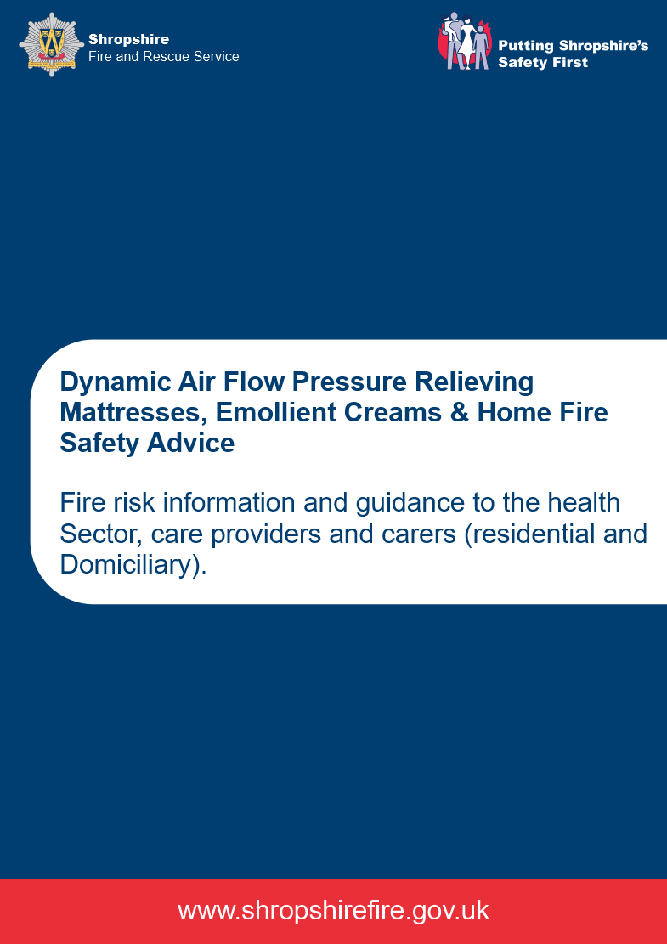

Introduction

In the past four years there have been several fire incidents across the United Kingdom attributable to the use of Dynamic Air Flow Pressure Relieving Mattresses in the domestic (home) environment, many of these were fatal incidents.

This guidance will assist in the identification and reduction of fire risk when caring for individuals who use Dynamic Air Flow Pressure Relieving Mattresses or other similar air flow equipment such as; cushions and foam, fluid or gel filled mattresses.

This guidance is also relevant to the care of those individuals that spend extended periods of time in bed, or are bed bound, due to illness and impaired mobility, regardless of whether they use Dynamic Air Flow Pressure Relieving Devices, other pressure relieving devices, or standard mattresses.

What are Dynamic Air Flow Pressure Relieving Mattresses?

Dynamic Air Flow Pressure Relieving Mattresses (and overlays placed on top of standard mattresses) are for prevention and treatment of pressure ulcers (bedsores) to people who spend extended periods of time in bed due to illness and impaired mobility. They are commonly used in hospitals, hospices and residential care homes but are also provided for use in the home. They are filled with air by a pump and use dynamic, controlled air pressure cells to adjust positioning according to the patient’s needs.

What is the problem in relation to fire?

The most common cause of the incidents referred to previously was smoking in bed. Others have included a hot hairdryer being placed on the bed, and a television which caught fire resulting in melted plastic falling onto the bed.

In all incidents, it is believed that the air released, when the mattress was punctured by the ignition source, caused the fire to spread more quickly and intensely. When a mattress is punctured and loses air, the pump reacts by working harder to replace the air, further fueling the fire. In addition, the mattress pump contains a battery back-up so that if the electricity supply fails, the pump continues.

As this equipment is generally provided to people who spend extended periods of time in bed due to illness and impaired mobility, they will be unlikely to be able to respond in a fire or escape without assistance. When the equipment provided in the home, living alone or being alone in the property is a risk that must be considered.

Shropshire Fire & Rescue Service advises that;

- When this equipment is provided for use in the home, the assessment undertaken must routinely include a specific section on fire safety.

- The differences between the home environment and a hospital or residential care environment must be considered. For example, an individual will not be permitted to smoke in hospital but may choose to smoke in bed at home.

- Household items which could start a fire such as candles or some electrical equipment would not usually be present in a hospital or residential care setting.

- In the event of a fire in a hospital or residential care setting, members of staff are usually summoned by a fire alarm to render immediate assistance.

Emollient creams

Emollient creams are treatments applied to the skin and are used to treat dry skin conditions such as eczema. They reduce water loss from skin by covering it with a protective film. The use of emollient creams is common amongst people who spend extended periods of time in bed due to illness and impaired mobility.

Individuals using paraffin-based emollients should be advised to keep away from fire or flames as dressings and clothing can be easily ignited. Bedding, including bottom sheets, can become impregnated increasing flammability.

Individuals who smoke should be made aware of the added fire risk associated with smoking and using emollient creams.

More information can be found on the National Patient Safety Agency (NPSA) Website.

Further Guidance & Recommendations

- Fire Safety must be a feature of all premises and patient centered risk assessments.

- Risk assessments must consider the individual’s environment, behaviours and the risk they pose to others, not just themselves. The difference between a hospital, residential care setting and the home must be taken into account.

- Provide fire retardant bedding to reduce fire risk. It is recommended that those prescribing and providing dynamic air flow pressure relieving mattresses and emollient creams work with care providers to ensure this is in place. Provide adequate bedding to account for a change of bedding during laundry.

- Make a referral for a Home Fire Safety Visit (HFSV). Shropshire Fire & Rescue Service delivers HFSVs to individuals who may be at heightened risk from fire. HFSVs provide advice and support to reduce risk and improve fire safety awareness in the home. Free smoke detection may be fitted, if required.

- HFSVs are most effective when completed alongside a health or social care professional, a carer, or both. It is recommended that those making a referral participate in a joint visit with Shropshire Fire & Rescue Service staff. This ensures that fire safety interventions and clinical interventions are integrated and do not compromise each other.

General Fire Safety Advice

- Keep ignition sources away from the bedding and mattress or any bedding or clothing likely to be impregnated with emollient cream.

- Don’t smoke in, or on the bed. If an individual is insistent on smoking they should smoke away from the bed and mattress and only when a capable person is with them to offer immediate assistance if required. Smoking when wearing clothing impregnated with emollient cream must not be undertaken.

- Don’t burn candles in the room where the bed or mattress is kept or in proximity to any items impregnated with emollient creams.

- Don’t have electrical equipment in the vicinity of the bed, mattress or any bedding or clothing likely to be impregnated with emollient cream.

- Don’t use electric blankets in combination with the bed, mattress or any bedding or clothing likely to be impregnated with emollient cream.

- Don’t overload plug sockets.

- Ensure essential electrical items are maintained and switched off and unplugged at the mains when not in use

- Don’t have fires and heaters in the vicinity of the bed, mattress or any bedding or clothing likely to be impregnated with emollient cream.

- Don’t place hot items such as hairdryers or heated hairstyling appliances, on the bed, mattress or any bedding or clothing likely to be impregnated with emollient cream.

- If you use a mobility aid, keep it within reach.

- If a fire should occur, if it is safe to do so, turn off the pump.

Smoke Detection

Some households will have mains or battery operated smoke detection. It is recommended that a HFSV is carried out to assess whether detection is adequate.

When caring for householders with limited mobility, consideration should be given to the provision of inter-linked smoke alarms connected into a tele-care, care-call or life-line type system.

Do you know someone at risk from fire?
Whether you’re a professional working with a vulnerable client, a landlord with tenants who could be at risk or look after a friend or family member in their home, Shropshire Fire and Rescue Service can help.
The following are some risk factors that may be apparent:
- Targeted arson attack, or threat of arson.
- Fire-setting activity within the household.
- Unsafe home oxygen use.
- Lack of working smoke detection in the property.
- Burns to the person, clothing, bedding, carpets or furniture.
- Overflowing ashtrays or cigarettes lying discarded around the property.
- Immobility affecting the ability to escape in a fire.
- Air-filled pressure relieving mattress user
- Emollient cream user
- Unsafe cooking practices such as pans or grill being left on when not in use.
- Candle use for economic reasons.
- Hoarder.
This is not an exhaustive list, contact the Service for further advice and support.

What you should do:
- Explain the risk to the person and take any immediate steps to reduce the risk.
- Obtain consent for you to contact Shropshire Fire & Rescue Service for a Home Fire Safety Visit (HFSV)
- Call us on 01743 260200 and speak to a SFRS Vulnerable Persons Officer.
- Explain to the person receiving the call that you wish to arrange a HFSV
- When making a HFSV referral you must provide the following:
- Your name and your agency.
- Confirmation of householder consent.
- Householder details; their name, address, post code and a contact number.
- The post code is essential so that the request can be assigned for completion.
- Your contact details so that someone can contact you to confirm the appointment.

Data Privacy Information.
Shropshire Fire & Rescue Service works to keep people safe at home, on the roads and in the community. In order to do this work we will often need the name and address of our service users.
To ensure people get the right services we may ask for further information such as age and any health requirements. This helps us to understand what people’s needs are and who else may be able to help.
We work closely with other agencies, and may offer assistance from other agencies such as Councils, Health Services, Adult & Children’s Services or Age Concern. We will usually explain if we want to share personal information with other agencies and allow people to say no if they prefer. This may mean that people will not get all the help they may need.
There are some circumstances where we will not be able to ask for agreement. This is where the law requires us to contact other agencies, usually relating to crime or where there is a serious risk to personal safety.
Want to know more?
We recognise that people trust us to handle information correctly and keep it safe. We will not use information for marketing, and we will only use it for the purpose we collected it.
If you want to know more details about how we use personal information, or if you would like to opt out of any of our services, please either –
- visit www.shropshirefire.gov.uk or
- contact Prevention on 01743 260200

Further Information.
Home Fire Safety Visits – we record name, and address and any details about risks in the home, such as smoking, use of oxygen or disabilities.
We may share information with other agencies who can provide more help, and we will usually give the house holder the chance to say no if they don’t want us to share information. If house holders don’t want to give us information we may be unable to fully assist.
iLearn – Includes working with children and young people who may be at risk of causing fires to try and change their behaviour. These individuals may have been referred for our iLearn work by the parent/guardian, school, Police or Children’s Services, or because we are concerned about a fire incident. We only provide iLearn work with parent/guardian agreement and we aim to include parents or guardians in our work. The iLearn course is not exclusive to fire setters. Youngsters who have been the victim, witnessed or been involved in a fire often become traumatized and their behaviours altered. The iLearn course now attempts to counsel and support these children.
We recognise the privacy rights of those aged under 18. We must retain records of any work with children or young people in case of future queries.
We may have to share iLearn information with other agencies if there is a significant risk or if we are required by law. Where possible we will advise before we share information but there may be exceptions to this.
Safeguarding Referrals – in cases of abuse or neglect or where we feel the making of a safeguarding referral is appropriate we will refer matters to the local authority in accordance with Adult or Children’s Services referral procedures.

