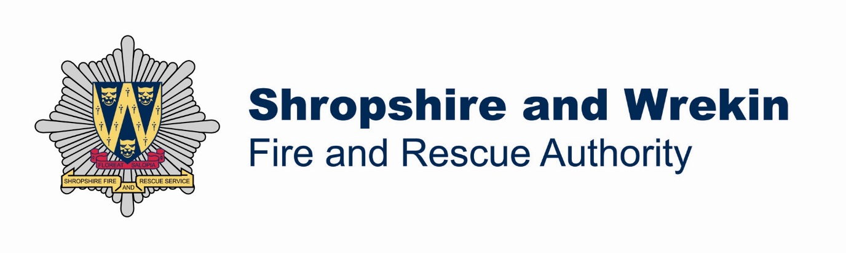

Section 3

Committee Membership and Constitution

Contents
Committee Membership and Constitution 1
Shropshire and Wrekin Fire and Rescue Authority Committee Structure 5
Shropshire and Wrekin Fire and Rescue Authority Committee Membership 1
Strategy and Resources Committee 4
Audit and Performance Management Committee 8
Standards and Human Resources Committee 10
Brigade Managers’ Employment Panel 15
Pensions Panel 16
Strategic Risk and Planning Working Group 17
Shropshire Fire Risk Management Services 19

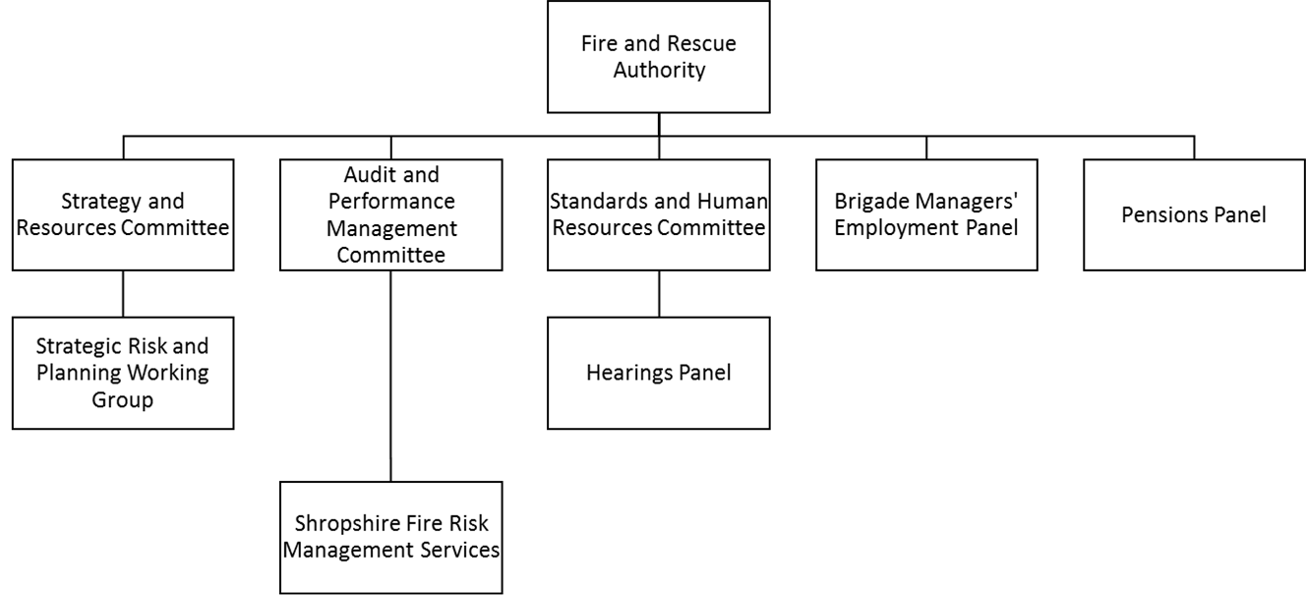

Shropshire and Wrekin Fire and Rescue Authority Committee Structure

Shropshire and Wrekin Fire and Rescue Authority Committee Membership

Key: = Member C = Chair VC = Vice Chair

Members | Strategy and Resources | Audit and Performance Management | Standards and Human Resources | Pensions Panel | Brigade Managers Employment Panel | Strategic Risk and Planning Working Group
Peter Adams |  |  | C
Keith Austin
Joyce Barrow |  |  | VC
Martin Bennett
Frances Bould
Eric Carter | C
Nigel Hartin | VC |  |  |  |  | C
John Hurst-Knight
Jean Jones |  | C
Terry Kiernan
Chris Mellings |  | VC
David Minnery
Mal Price |  |  |  |  |  | VC
Gilly Reynolds
John Thompson
Stuart West |  |  |  |  | C
Paul Wynn
Number of Members | 7 | 7 | 7 | 3 | 7 | 8

Strategy and Resources Committee

Quorum - 4

Members – 7

Joyce Barrow (Conservative)
Eric Carter (Conservative) (Chair)
Nigel Hartin (Liberal Democrat) (Vice Chair)
David Minnery (Conservative)
Gilly Reynolds (Labour)
John Thompson (Labour)
Stuart West (Conservative)

Members of the Fire Authority’s Audit and Performance Management Committee are precluded from sitting on the Strategy and Resources Committee and vice versa.

Meeting Dates

2014
6 February
13 March
19 June
18 September
20 November

All meetings take place at 2.00 pm at Service Headquarters, unless otherwise advised.

Terms of Reference

To consider and make recommendations to the Authority on its strategic direction

To consider any recommendations in relation to changes of service emanating from the Integrated Risk Management Planning Process

To receive, comment upon, and note the Medium Term Corporate Plan

To consider and recommend to the Authority an annual financial planning strategy

To review forward revenue and capital budgets for consideration by the Authority, including considering reports from officers, and make recommendations to the Authority on:

- Base budget and committed change
- Pay and prices assumptions
- Efficiencies
- Service developments
- Capital programme
- Robustness of the budget and adequacy of provisions, reserves and funds

To consider revisions to the revenue budget and final budget plan and finalise a revenue budget proposal for consideration by the Authority

To consider and propose the three-year capital programmes, Prudential Guidelines, including Treasury Management Strategy Statement, Investment Strategy and Policy on Minimum Revenue Provision for recommendation to the Authority and to monitor performance in accordance with those Guidelines, Statements, Strategies and Policies

To oversee, review, and make recommendations to the Authority on, the management of all financial and physical resources

To have an awareness of the risks faced by the Fire Authority through receiving reports on corporate risk management

To monitor budgeting and financial performance, consider any actions proposed by officers and make recommendations to the Authority, where appropriate, including reporting any virements to the Authority for approval

To consider national, regional and local procurement strategies

To receive and consider reports on exemptions agreed by the Chief Fire Officer and Treasurer in consultation with the Chair of the Fire Authority under the Authority’s Standing Orders relating to Contracts and advise as appropriate

To consider value for money issues

To review Authority Public Value measures annually for recommendation to the Authority

To receive reports on any financial implications of decisions made by the Authority’s Pensions Panel

To review the Terms of Reference of the Committee as required or at least annually and make recommendations to the Authority regarding amendments

To review and agree the role descriptions of the Committee’s Chair and Vice-Chair and of the Chair of the Strategic Risk and Planning Working Group

To approve the Committee’s annual work plan

To investigate and report upon any other matter specifically referred to the Committee by the Authority

To ensure the provision of appropriate training and development to ensure that all Members of the Committee are able to discharge their responsibilities

Audit and Performance Management Committee

Quorum - 4

Chair

The Chair of the Committee shall be elected from a member of the largest opposition group.

Members - 7

Peter Adams (Conservative)
Keith Roberts (Conservative)
Frances Bould (Labour)
John Hurst-Knight (Conservative)
Jean Jones (Labour) (Chair)
Terry Kiernan (Conservative)
Chris Mellings (Liberal Democrat) (Vice Chair)

Members of the Fire Authority’s Strategy and Resources Committee are precluded from sitting on the Audit and Performance Management Committee and vice versa.

Meeting Dates

2014
27 March
12 June
11 September
6 November

Members may request a meeting with Internal and External Audit without Fire Service officers present.

All meetings take place at 2.00 pm at Service Headquarters, unless otherwise advised.

Statement of Purpose

Audit*

To provide an independent and high-level resource to support good governance and strong public financial management

To provide those charged with governance independent assurance on the adequacy of the risk management framework, the internal control environment and the integrity of financial reporting and annual governance processes.

*As defined in the Chartered Institute of Public Finance and Accountancy (CIPFA) Audit Committees: Practical Guidance for Local Authorities and Police (2013)
Performance Management

To oversee the process of assessing progress toward achieving the Fire Authority’s predetermined aims, as set out in the Service Plan. The Committee’s role involves building on that process, adding the relevant communication and action on the progress achieved against the predetermined aims.

Audit Core Functions*

To be satisfied that the Fire Authority’s assurance statements, including the Annual Governance Statement, properly reflect the risk environment and any actions required to improve it, and demonstrate how governance supports the achievement of the Fire Authority’s objectives

In relation to the Fire Authority’s internal audit functions:

- To oversee its independence, objectivity, performance and professionalism
- To support the effectiveness of the internal audit process
- To promote the effective use of internal audit within the assurance framework

To consider the effectiveness of the Fire Authority’s risk management arrangements and the control environment. To review the risk profile of the organisation and assurances that action is being taken on risk-related issues, including partnerships with other organisations

To monitor the effectiveness of the control environment, including arrangements for ensuring value for money and for managing the Fire Authority’s exposure to the risks of fraud and corruption

To consider the reports and recommendations of external audit and inspection agencies and their implications for governance, risk management or control
To support effective relationships between external audit and internal audit, inspection agencies and other relevant bodies, and encourage the active promotion of the value of the audit process

To review the financial statements, external auditor’s opinion and reports to Members, and monitor management action in response to the issues raised by external audit

* As defined in the Chartered Institute of Public Finance and Accountancy (CIPFA) Audit Committees: Practical Guidance for Local Authorities and Police (2013)

Standards and Human Resources Committee

Quorum - 4

Members - 7

The Committee is politically balanced.

Peter Adams (Conservative) (Chair)
Keith Austin (Labour)
Joyce Barrow (Conservative) (Vice Chair)
Frances Bould (Labour)
Terry Kiernan (Conservative)
Chris Mellings (Liberal Democrat)
Mal Price (Conservative)

Independent Person

C Humphries

The Independent Person, whom the Fire Authority shares with Telford & Wrekin Council, is not a member of the Standards and Human Resources Committee or the Fire Authority but can be approached to give an independent view about standards issues, either by the Monitoring Officer or the Member, about whom a complaint has been made.

Meeting Dates

2014
8 April
21 October

All meetings take place at 2.00 pm at Service Headquarters, unless otherwise advised.

Terms of Reference

To review at least annually, and more frequently, if changes are required sooner, its terms of reference to ensure that they are up-to-date, and make recommendations for change to the Fire Authority

To review and agree the role descriptions of the Committee’s Chair and Vice-Chair

To ensure the provision of appropriate training and development to all Members of the Committee to enable them to discharge their responsibilities

To exercise such other functions as the Authority considers appropriate
Standards

To promote and maintain a high standard of conduct by Members, to oversee the Register of Members’ Interests and to oversee the effectiveness of the Authority’s procedures for investigating and responding to complaints about Members

To advise the Authority on the adoption or revision of the Members’ Code of Conduct

To assist Members to observe the Members’ Code of Conduct

To advise, train, or arrange to train Fire Authority Members on matters relating to the Members’ Code of Conduct

To develop, maintain and monitor the operation of such Code

To issue advice to Members on the treatment of disclosable pecuniary interests and on conduct matters generally

To oversee the process for the recruitment of an Independent Person and make recommendations to the Fire Authority for their appointment

To consider and grant, or otherwise, dispensations in respect of Members’ interests where:

- The dispensation is in the interests of persons living in the area of the Fire Authority; or
- It is otherwise appropriate to grant a dispensation

To receive reports from the Monitoring Officer about:

- Complaints
- The progress and outcome of investigations
- The establishment and maintenance of the Register of Interests of Members of the Fire Authority
- Dispensations granted to Members of the Fire Authority

To consider any application received from any officer of the Authority for exemption from political restriction under Sections 1 and 2 of the Local Government and Housing Act 1989 in respect of the post held by that officer and may direct the Authority that the post shall not be considered to be a politically restricted post and that the post be removed from the list maintained by the Authority under Section 2(2) of that Act

To review at least annually the Role Description and Skills and Competencies for Independent Persons and make recommendations to the Fire Authority regarding any amendments required

To review the Protocols on Gifts and Hospitality and Member / Officer Relations and make recommendations to the Fire Authority regarding any amendments required

To review and amend, where required, the processes and procedures for dealing with complaints against Members

Human Resources

To consider human resource strategies and make recommendations to the Authority

To consider reports on the progress of regional and national human resource activities and make recommendations to the Authority, where appropriate

To consider and monitor staffing requirements, the establishment scheme and human resource policies for the Authority and make recommendations to the Authority

To consider fundamental amendments to locally determined conditions of service and make recommendations to the Authority

To consider reports regarding the induction, training and development needs of Members and officers, regularly review those needs and make recommendations to the Authority

To ensure that equality of opportunity and diversity at work issues are promoted, implemented and monitored by the Authority and the Service

To review at least annually the Role Description of the Fire Authority’s Equality and Diversity Champion and make recommendations to the Fire Authority regarding any amendments required

To consider reports on employee pension schemes and make recommendations to the Authority

To receive reports on Occupational Health provision and make recommendations to the Fire Authority, where appropriate

To review and amend, where required, the processes and procedures for dealing with:

- Appeals against grading and market factor supplement decisions
(including rank to role)
- Grievances
- Appeals against the application or interpretation of conditions of service
- Appeals against dispute in accordance with the Collective Disputes Procedure
- Appeals Hearings cases

Hearings Panel

Quorum – 3

Members – 7

Although all Members of the Standards and Human Resources Committee will be eligible to participate in appeals hearings, the number participating in any hearing will be limited to 3. Steps will be taken to ensure that, wherever practicable, political balance is achieved. The need to hold a hearing as quickly as possible will, however, take precedence over this.

Terms of Reference

Appeals Hearings relating to Employees

To undertake the following functions which apply to those employees who come within the jurisdiction of the Fire Authority:

- To consider and determine appeals against grading and market factor supplement decisions

- To consider and determine grievances in accordance with the Grievance Procedure

- To consider and determine appeals against the application or interpretation of conditions of service

- To consider and determine any appeal against a decision of a Brigade Manager / Brigade Managers relating to individual cases of long-term sickness and pay

- To consider and determine any appeal against a decision of a Brigade Manager / Brigade Managers relating to the ill-health retirement or dismissal for health-related reasons of any employee

- To consider and determine any appeal against a decision of a Brigade Manager / Brigade Managers relating to powers exercised under firemen’s and firefighter pension scheme legislation and related legislation in respect of ill-heath retirements, except where that appeal is against a medical decision

- To consider and determine appeals at Internal Dispute Resolution Procedures Stage 2 with regard to the firemen’s and firefighter pension schemes and the Firefighters’ Compensation Scheme

- To consider and determine appeals against dismissal under the disciplinary process

- To consider and determine appeals against dispute in accordance with the Collective Disputes Procedure

Complaints relating to Members

To consider complaints referred to them by the Monitoring Officer and to decide if the complaint should be referred for investigation

To consider investigation reports in respect of Code of Conduct complaints referred to the Committee by the Monitoring Officer

To report its findings to the Fire Authority, as appropriate, for information

Where a breach is found, to make decisions about sanctions, including:

- To make recommendations to the relevant Group Leader regarding future membership of committees and sub-committees

- To make recommendations to the Fire Authority regarding the removal of a non-aligned Member from membership of committees and sub-committees

- To instruct the Monitoring Officer to arrange training for a Fire Authority Member

- To remove a Member from all outside appointments to which he / she has been appointed or nominated by the Fire Authority

- To withdraw facilities provided to the Member or exclude the Member from defined premises (except as necessary for the Member to attend formally constituted Authority meetings)

Brigade Managers’ Employment Panel

Quorum – 3

Members - 7

Peter Adams | Chair of Standards and Human Resources Committee (Conservative)
Keith Austin | (Labour)
Joyce Barrow | (Conservative)
Nigel Hartin | (Liberal Democrat)
David Minnery | Vice-Chair of Fire Authority (Conservative)
Gilly Reynolds | (Labour)
Stuart West | Chair of Fire Authority (Conservative) (Chair)

Terms of Reference and Meetings

To meet as and when required to review the pay and conditions of service of Brigade Managers in accordance with the process agreed by the Fire Authority at its meeting on 3 July 2009, as may be amended by the Fire Authority from time to time, and, having carried out a review, to make decisions relating to the pay and conditions of service of Brigade Managers

To make recommendations to the Authority on the process for appointments to the posts of Chief Fire Officer, Deputy Chief Fire Officer, Assistant Chief Fire Officer, Treasurer, Monitoring Officer, Deputy Monitoring Officer and Clerk, as necessary

Pensions Panel

Quorum – 3

Members - 3

Peter Adams | Chair of Standards and Human Resources Committee (Conservative)
David Minnery | Vice-Chair of the Fire Authority (Conservative)
Stuart West | Chair of the Fire Authority (Conservative)

In the absence, or inability to act, of the Chair of the Human Resources Committee the Vice-Chair of the Committee may deputise for him.

Under a resolution made by the Fire Authority on 15 June 2011 and at each Annual Meeting thereafter the Pensions Panel is not subject to the political balance requirements.

Terms of Reference

To make decisions and exercise discretionary powers arising from employee pension scheme legislation

Meeting Dates

There are no scheduled meeting dates for the Pensions Panel, which meets on an “ad hoc” basis as and when there are cases to consider.

Reporting

All decisions of the Pensions Panel will be reported to the Fire Authority and, where there are financial consequences for the Fire Authority, also included in the monitoring report on financial issues to the Strategy and Resources Committee, to enable the Committee to consider any implications for resources.

Strategic Risk and Planning Working Group

Quorum – 4

Members – 8

Joyce Barrow (Conservative)
Eric Carter (Conservative)
Nigel Hartin (Liberal Democrat) (Chair)
Jean Jones (Labour)
Mal Price (Conservative) (Vice Chair)
John Thompson (Labour)
Stuart West (Conservative)
Paul Wynn (Conservative)

Terms of Reference

To consider strategic planning and Integrated Risk Management Planning issues, ensuring that Equality and Diversity, Public Value and IRMP criteria are taken into account

To consider all aspects of the budget setting process

To consider ways to deliver financial efficiencies identified by the Strategy and Resources Committee

To consider national, regional and local service delivery requirements as set out within Fire and Rescue National Framework

To review and monitor existing strategic planning and Integrated Risk Management Planning strategies

To oversee and review foreseeable risks to the strategic planning and Integrated Risk Management Planning strategies

To consider value for money issues

To review the Terms of Reference of the Working Group as required or at least annually

To review annually the role description for the Working Group’s Chair

To investigate any other matter specifically referred to the Working Group by the Strategy and Resources Committee or the Fire Authority

To ensure the provision of appropriate training and development to ensure that all Members of the Working Group are able to discharge their responsibilities

Meeting Dates

The Working Group will meet as and when required.

Its Members will also participate in the extensive consultation exercise, which emanates from the strategic planning and Integrated Risk Management Planning processes and each Member will be expected to attend a minimum of six consultation events per year.

Accountability

The Working Group’s findings will be reported to the Strategy and Resources Committee or, where this is not feasible, direct to the Fire Authority

Shropshire Fire Risk Management Services

Local Authority Controlled Company

Shropshire Fire Risk Management Services (SFRMS) is the commercial trading arm of Shropshire Fire and Rescue Service. SFRMS operates as a Local Authority Controlled Company (LACC) and began trading on 16 July 2013.

Board of Directors

The LACC’s Board of Directors consists of 5 Fire Authority Members, who are appointed as per the following criteria, which were agreed by the Fire Authority at its April 2013 meeting:

- That, in perpetuity, one of the five seats on the Board should be taken by a Member of Shropshire Council and one by a Member of Telford & Wrekin Council
- That the Vice-Chair of the Fire Authority should sit on the Board
- That the remaining 2 seats should be decided by a free vote

Members of the Board of Directors

Joyce Barrow | Shropshire Council
Nigel Hartin | Shropshire Council
Terry Kiernan | Telford & Wrekin Council
Chris Mellings | Shropshire Council
David Minnery | Shropshire Council Vice-Chair of Fire Authority (Chair of Board)

The Fire Authority will at its Annual Meeting review the membership of the Board of Directors.

Reporting Procedures

At its meeting in September 2013 the Fire Authority agreed that the company should report quarterly to its Audit and Performance Management Committee. The Board has agreed that, in the interests of openness and transparency, it should also provide regular updates on company progress to the full Fire Authority.

