Shropshire and Wrekin Fire and Rescue Authority
10 December 2014

Rescue Tender Crewing Review

Report of the Chief Fire Officer

For further information about this report please contact Chief Fire Officer John Redmond on 01743 260201, or Deputy Chief Fire Officer Rod Hammerton on 01743 260204.

- Purpose of Report

This report provides an update on the impact to the public following a decision to no longer primary crew the Rescue Tender (RT).

Recommendations

The Fire Authority is asked to agree the following recommendations:

- To recognise the feasibility of continuing to “switch crew” the RT whilst recognising the potential negative impacts;

- To support a decision to continue to “switch crew” the RT; and

- To support a decision that should future resource levels allow, a return to primary crewing the RT, on a permanent or temporary basis, should be considered.

- Background

One of the most significant changes within the 2010 Public Value programme involved changes to the crewing of the RT at Wellington. Savings of £297k were realised by reducing staffing levels at Wellington by eight operational posts. In order to achieve this reduction the Service has frozen recruitment, with the last intake of Wholetime Duty System (WDS) recruits dating back to 2010.

Whilst it was acknowledged that these were significant savings at a time of financial uncertainty, this decision was only agreed as a least preferred option after much debate, consultation and deliberation and a number of Fire Authority Members were concerned as to the potential impact on public safety of its removal. The proposed removal of the RT also caused concern across the workforce during the consultation phase.
As a result of this, the Authority agreed that the removal of the primary crewing arrangement would be put back until 2014. The reasoning behind this lay in that, should the financial situation become more predictable and the future of the Service become more financially secure, the decision could be reversed.

Currently, Wellington can respond to an incident, which requires rescue, having taken a local decision on which appliance provides the most appropriate capability. This may be either the pumping appliance, the RT, or both, depending on the nature and details of the incident. A crew of five would cover both appliances.

It was also agreed that, once implemented, the change would be subject to review and the Fire Authority should receive regular reports on the impact of the change.

- Data Analysis

The RT was mobilised 219 times out of a total of 3,027 incidents between
2 January and 1 November 2014. An average time of 20 minutes from mobilisation to attendance was achieved throughout the County.

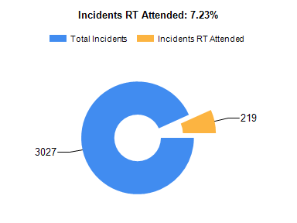

When the Tender did attend an incident, RT specific equipment was used on 89 occasions and on more than 40% of these the enhanced equipment carried on the RT had a significant affect in the extrication of casualties.

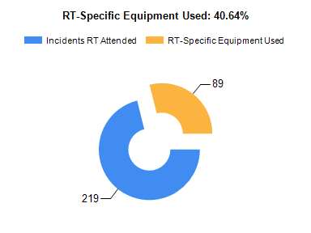

In order to maintain the availability of the RT, Wellington has been removed from the requirement to provide relief and Firefighter Assist Support Team (FAST) duties. Having measured the impact of this decision on other WDS staff, between 2 January and 1 November 2014, there were no occasions when crews have been on relief duties, and two occasions when crews have been on FAST duties. It is reasonable to assume that, given the current level of fire cover, the impact on other crews has been minimal.

However, it should be recognised that, any future changes to the crewing model, as a result of 2020 Integrated Risk Management Planning (IRMP), could impact negatively on this position, with a greater demand placed on remaining crews.

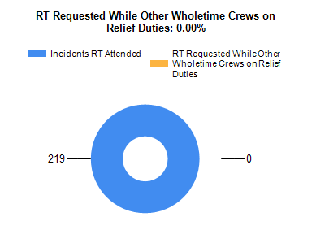

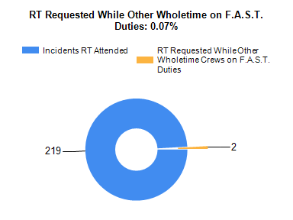

Over the past 12 months, Wellington has continued to engage with the local communities undertaking community fire safety and business fire safety work, along with school education visits. If the RT is required during this time, the crew will return to station to collect the RT and proceed to the incident.

This method of mobilising can delay the arrival of the RT at incidents. Out of the 219 RT mobilisations the crew at Wellington had to return to the station
14 times to crew the RT. On these occasions the Service has not been made aware of any detrimental effect on public safety. However, the Service recognises that there will be circumstances, where the significant delay of heavy rescue equipment could have an impact on the outcome of an incident.

- Summary of the 12 Month Trial

Following the 12 month trial it has been shown that for that period:

- Little detrimental impact on public safety has been measured;

- The attendance of the RT has been delayed on a very limited number of occasions; and

- There has been no significant impact on the workloads of other stations, covering relief and FAST duties.

- Corporate Issues

In order to meet budgetary restrictions the staff establishment has been progressively reduced over the last few years through initiatives such as “switch crewing” the RT. This planned reduction has led to a lack of recruitment of new entrants, which in turn has led to a situation whereby the number of staff able to demonstrate the abilities to achieve progression through the Service is becoming adversely affected. This may led to a point where the Service chooses to recruit above establishment for a period.

It should also be recognised that as the WDS Crewing Pattern Review progresses and an Integrated Crewing Model is developed there may be periods where additional resources are generated.

Should either of these events arise it would make sense to consider usefully deploying these additional resources to return the RT to primary crewing, either on a permanent or temporary basis dependant on any competing priorities at that time.

- Financial Implications

Maintaining the RT as “switch crewed” supports the Medium Term Financial Plan.

- Conclusions

The review period has adequately demonstrated that “switch crewing” of the RT does not present any risks that are outside of a tolerable range.

However the review did point to the potential for there being occasions where a more assured immediate response might have benefits.

Therefore the recommendations of the review are that the RT should continue to be “switch crewed”. However if the Service was in a position whereby resources supported returning the RT to immediate response, whether on a permanent or temporary basis, this should be considered.

- Legal Comment

There are no legal implications arising from this report.

- Initial Impact Assessment

An Initial impact Assessment has been completed.

- Equality Impact Assessment

There are no equality or diversity implications arising from this report. An Equality Impact Assessment is not, therefore, required.

- Appendices

There are no appendices attached to this report.

- Background Papers

There are no background papers associated with this report.

