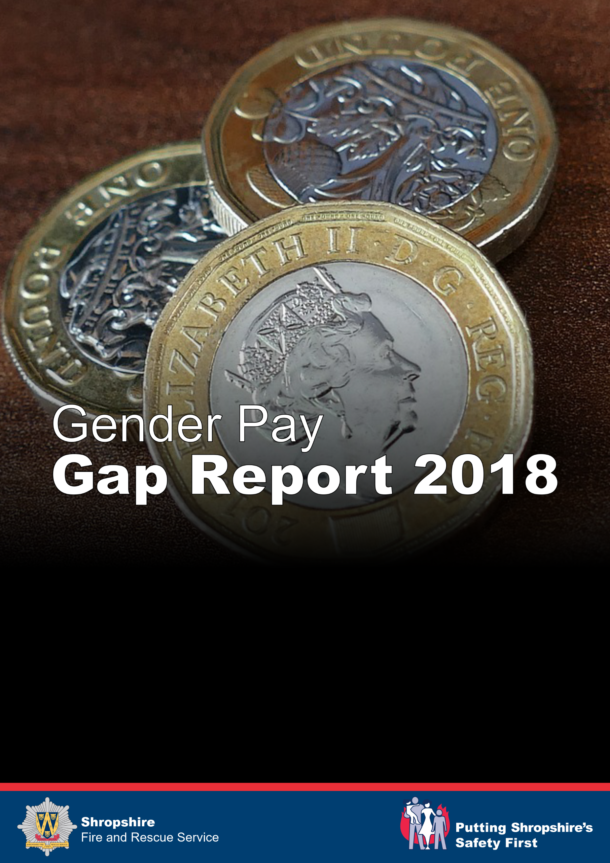

Gender Pay Gap Report

Introduction

The Equality Act 2010 (Gender Pay Gap Information) Regulations 2017 came into force in April 2017. This requires us as an organisation with 250 or more employees to publish annual statutory figures in relation to the gender pay gap. We are committed to publishing this information annually on both the government website and Shropshire Fire and Rescue Service’s website.

The gender pay gap is an equality measure that shows the difference in average earnings between women and men. Used to its full potential, gender pay gap reporting is a valuable tool for assessing levels of equality in our workplace, female and male participation, and how effectively talent is being maximised.

“Shropshire Fire and Rescue Service are committed to ensuring and achieving a diverse workforce and proactively target opportunities to encourage female representation across all levels of the organisation. We continue to work towards closing the gender pay gap through our targeted action and recruitment processes and focus on ensuring our policies are inclusive and support the needs of all staff.

The initiatives outlined in this report support our commitment to closing the gender pay gap and forms part of our ongoing People strategy”.

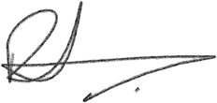
Rod Hammerton
Chief Fire Officer

Gender Pay Gap Information

The required figures are calculated using a specific reference date called the
“snapshot date”. This date was set nationally by Government as 31 March 2017 and SFRS are required to use this date and to provide and publish figures based on the following:

The mean gender pay gap – The difference between the mean hourly rate of pay of male employees and that of female employees as a percentage.

The median gender pay gap – The difference between the median hourly rate of pay of male employees and that of female employees as a percentage.

The mean bonus gender pay gap – The difference between the mean bonus pay paid to male employees and that paid to female employees as a percentage.

The median bonus gender pay gap – The difference between the median bonus pay paid to female employees as a percentage.

Bonus proportions – The proportion of male and females receiving a bonus payment

(SFRS do not offer a bonus scheme and therefore are not required to report on bonus percentage figures.)

For the purposes of statutory reporting requirements SFRS must publish figures based on individual employee contracts of employment. The figures below are based on all established contracted posts within the Service. This includes Support staff, wholetime / retained firefighter dual roles and secondary employment contracts, such as associate trainers.

Total Employees

Gender | Total
Female | 105
Male | 610
Total | 715

SFRS Mean and Median gender pay gap

The following tables outline the mean and median gender pay gaps both with and without flexible duty allowances for Flexi Duty System (FDS) officers. Without the allowances the median figure stays the same but the male mean average reduces from £14.10 to £13.95 and pay gap changes from 8% to 7%.

Figures within the tables contain all staff including retained, whose hourly rates of pay are reflected as per the pay scales issues by the National Joint Council for Local Authority Fire and Rescue Services.

With allowances | Female | Male | Gap | %
Average Hourly Rate (Mean) | 13.04 | 14.10 | - 1.06 | 8%
Median | 12.01 | 13.53 | - 1.52 | 11%

Without 20% FDS allowances | Female | Male | Gap | %
Average Hourly Rate (Mean) | 13.04 | 13.95 | - 0.91 | 7%
Median | 12.01 | 13.53 | - 1.52 | 11%

SRFS mean gender pay gap is significantly lower than the reported national average of 18%, with SFRS female staff on average earning £0.91 an hour less than males. The above figures show that female staff on average earn 7% less than male staff.

The median pay gap shows that male staff are paid £1.52 more per hour than female counterparts and this is likely due to the higher number of male staff to female staff in senior operational roles.

SFRS believes that the gender pay gap does not arise from paying men and women differently for the same work, but it as a result of the roles in which they work and the salaries that these roles attract, especially within the non-uniformed departments. The lower than average mean pay gap takes into account a female Executive Officer and the roles of female Heads of Departments and female Middle Managers in specialist areas such as HR, ICT and Finance.

Salary Quartile Bands - Overview
 | High | Mid (Upper) |  | Mid (Lower) |  |  | Low
Female | 9% | 10% |  | 3% |  |  | 36%
Male | 91% | 90% |  | 97% |  |  | 64%
Salary Quartile Bands - Breakdown
 | Hour Rate Range |  | Female |  | % Female | Male |  | % Male |  | Total
1 High | £15.00 - £55.14 |  | 16 |  | 9% | 163 |  | 91% |  | 179
2 Mid Upper | £13.53 - £15.00 |  | 18 |  | 10% | 160 |  | 90% |  | 178
3 Mid Lower | £13.53 |  | 6 |  | 3% | 173 |  | 97% |  | 179
4 Lower | £4.00 - £13.53 |  | 65 |  | 36% | 114 |  | 64% |  | 179
 |  |  | 105 |  | 15% | 610 |  | 85% |  | 715

The above quartile tables indicate that males are the highest earners in SFRS. This reflects the larger number of male operational Middle Managers, however, in contrast there is a higher percentage of males in the lower quartile which covers our apprenticeships roles and on-call retained firefighters. A higher proportion of males undertake the on-call firefighter role and our percentage figure for apprenticeships is higher for males than females.

The lower quartile indicates our largest female percentage area and mainly equates to our support staff, some of whom are in lower grade administrative roles and all who are contracted to the National Joint Council (NJC) Green book terms and conditions. These terms and conditions of employment offer lower rates of pay in comparison to operational roles, which are governed by NJC Grey book terms and conditions. The operational roles offer higher rates of pay at entry point in comparison to non-operational support staff posts. There is also a higher number of part-time females in this quartile, which indicates that females are more likely to take advantage of our family friendly policies.

The mid upper quartile band indicates 10% are female, these are in support staff specialist roles attracting mid-range salaries for specialist skills. It is recognised that females are underrepresented in uniformed roles and SFRS are addressing this through our recruitment strategies and in our 2018 wholetime recruitment campaign.

Initiatives to address the Gender Pay Gap

Our recruitment processes focus on attracting women into the Service by ensuring targeted positive action awareness / taster sessions and have been in place since 2003. SFRS also ensure managers involved in the recruitment processes have undertaken unconscious bias training to ensure a consistent approach when conducting interviews.

Our internal policies currently support family and work life balance working practices, offering flexible working opportunities such as job share and part time working hours. As part of our current WT Recruitment campaign we are offering a number of WT contracts on a Job Share basis. This is not something that the Service has explored before but we are optimistic that this opportunity might assist in increasing the levels of female applicants i.e. those who are striving to have a career alongside managing their work life balance.

SFRS have recently introduced a flexible shift working rota for both the Wholetime and Fire Control which has allowed individuals the opportunity to review their working hours and plan ahead to incorporate childcare arrangements. SFRS maternity and adoption leave policy also offer individuals enhanced benefits; this, supported by career break schemes and parental and paternity leave, encourage applications from females.

SFRS are currently reviewing the promotion policy to improve development opportunities for all across the Service and to ensure a consistent and fair approach to access all levels of the promotion stages. SFRS have taken measures to address internal promotion opportunities within our Fire Control room by addressing higher tier progression, resulting in the promotion of a number of female staff.

We are also currently reviewing our Job Evaluation procedures looking at lower paid roles and the grading structure and the implications of the minimum and living wage in relation to these lower paid roles. For example, our apprenticeship rates of pay are based on the national minimum wage rather than the government set apprenticeship rates of pay.

SFRS created an Equality, Diversity and Inclusion (ED&I) Steering Committee over 9 years ago to drive forward gender equality initiatives, which is chaired by the Chief Fire Officer. This also includes a Fire Authority Member on the panel who champions diversity. The committee drive ED&I initiatives forward at a strategic level.

Summary and next steps

As has been stated earlier in the report the National Average sits at 18%.
Having completed this analysis SFRS are pleased with the results displayed so far at between 7 and 8%. The report outlines a large number of areas we are already working on to address the gap through retention and attraction initiatives. We will continue to address this moving forward via our recruitment strategies and internal review of processes.

