On Call Firefighter Information Pack
Fire Station

Contents

1 Shropshire Fire and Rescue Service Map – pg 2

2 The On Call Duty System – pg 3 - 4

3 Becoming an On Call Firefighter – pg 5 - 8

4 The On Call Firefighter Recruitment Process – pg 9

5 Training for an On Call Firefighter – pg 10

6 Information for Employers/ Partners/Families – pg 11 -12

7 Frequently Asked Questions – pg 13

8 Job Description including Safety Responsibilities and Firefighter
Role map – pg 14 - 19

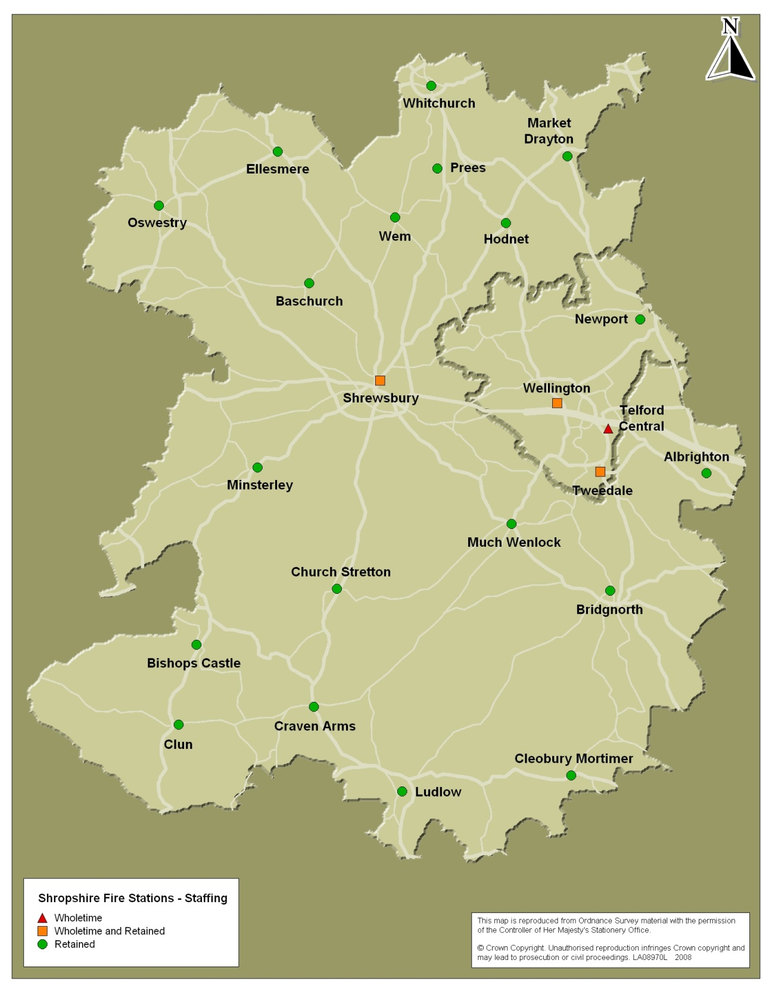
Shropshire Fire and Rescue Service

Shropshire’s On Call duty system provides essential fire cover in the county.

82% of Shropshire’s front line appliances are staffed by On Call Duty System personnel.

Of Shropshire’s 23 fire stations, 22 have the On Call Duty System compliment.

2 The On Call Duty System

The On Call Duty System is made up of men and women who do ordinary jobs and offer evening, daytime or weekend cover. They are ready to go out to a call the moment they are alerted through their pager. They may be at home, working for themselves or for a company.

On Call Firefighters are skilled men and women who work as an effective part of a team using the latest equipment, methods and techniques to undertake a wide range of duties, property fires, grass and farmland fires, road traffic collisions, chemical spills, animal rescues, floods and storm damage, community fire safety and many more.

On Call Firefighters are actively involved in the prevention of fire, particularly in the home. They undertake home fire safety risk assessments offering free advice to occupiers on how to eliminate or where this is not possible, reduce the risk of fire; this may involve the fitting of smoke detectors.

The role requires courage, determination, self-motivation and above all a desire to serve the community in which they live and possibly work.

Essential Requirements

- Be able to reach the Fire Station safely and legally within 5 minutes
- Aged 18 +
- Fit enough to carry out the role of a Firefighter
- Have enthusiasm to work in a team environment
- Willing to support and serve your community

What is involved?

You will be required to attend a weekly drill night for 2-3 hours at your appointed fire station for training and maintenance of essential equipment. When you are on call, you will be alerted by a pager and you will need to stop whatever it is you are doing and report immediately to the fire station.

We need at least 5 people to keep the fire appliance available to respond to emergency calls, and we also realise that everyone needs to balance their working life with their private life and that means being able to enjoy some quality time off. Currently there are two types of cover option, full cover which is 120+ hours per week and three-quarter cover which is anything less than 120 hours per week.

What’s in it for ME?

Firefighting is not like any other job, it can be unpredictable, exciting and rewarding, coupled with the satisfaction and respect that comes with providing a crucial service to the community. You will also learn new skills along the way, such as road traffic accident procedures, manual handling and fire safety which you may be able to use outside of the Fire and Rescue Service.

As a Firefighter, you receive an annual retainer fee, disturbance fees, and hourly rates for work undertaken, training session fees and reimbursement for 4 weeks annual leave, rising to 5 weeks when you complete five years consecutive service.

On Call Firefighter Pay rates from 1 July 2018

 | (1)  £ per  annum | (2)  £ per  Annum | (3)  £ per  Hour | (4)  £ per  occasion
Firefighter
Trainee | 2,291 | 1,718 | 10.46 | 4.02
Development | 2,386 | 1,789 | 10.90 | 4.02
Competent | 3,053 | 2,289 | 13.94 | 4.02

Column 1 shows the full annual retainer
Column 2 show the three quarter annual retainer
Column 3 shows the hourly rate for work undertaken
Column 4 shows the disturbance payment per call out

3 The On Call Firefighter Recruitment Process

The recruitment and selection of On Call Firefighters is dependent on the applicant either living and/or working close to one of the Services on call fire stations.

The recruitment process is as follows:

- You will need to apply online through the Shropshire Fire and Rescue Service website. You will need to complete each of the following forms:

- Application Form
- Equal Opportunities Form
- Fitness Questionnaire Form
- Declaration of Availability Form
- Rules on Drivers’ Hours and Tachographs Form.

- The Assistant Group Commander for your area is responsible for shortlisting; they will review your application and determine your suitability.

- You will be contacted in writing to inform you whether you have been successful or unsuccessful. If you are successful you will be invited to attend the job related tests (JRT’s).

- You will attend the Training and Development Centre for the JRT’s where you will undertake the written and physical tests.

- If you successfully pass the JRT’s, you will be invited to attend a medical at the Professional Centre, Pensfold, Gains Park, Shrewsbury.

- If you pass the medical you will be sent an offer of employment letter subject to current vacancies.

- You will be supplied with uniform and must attend drill nights at the station, two weeks prior to starting your training course.

- The training commences with the initial training course at the Training and Development Centre as detailed in the retained recruitment training programme (see appendix 1).

Shropshire Fire and Rescue Service (SFRS) is committed to equality and diversity at work. We positively welcome applications from disabled people and from minority groups who are under-represented in our Service.

4 Becoming a Firefighter

Initial application
The application form provides Shropshire Fire and Rescue Service (SFRS) with your personal details such as work history or qualifications. The application questionnaire asks you questions about your suitability for the role of Firefighter e.g. team working.
You will also be asked at the application stage to complete a declaration of any criminal convictions that you have that are unspent (under the Rehabilitation of Offenders Act 1974). This information will be considered should you be successful at the interview stage.
Any unspent convictions will be considered on an individual basis, taking into account the circumstances surrounding the offence. If you have a conviction that is now considered spent, this does not have to be declared.
SFRS have a legal duty to promote disability equality under the Equality Act 2010. This aligns with our commitment to valuing a diverse workforce, and providing the highest possible standards of service delivery’. Part of the application form will ask if you have any disabilities and these will be looked into by our Occupational Health Doctor on an individual basis. A decision will then be made as to whether you would be able to perform the duties of a Firefighter with any reasonable adjustments required.
Applicants who meet the essential requirements are invited to the next stage of the selection process.
Written Selection Tests

This section consists of different tests which assess your ability to process information, problem solve and work with numbers.

Physical / Practical Tests
The National Firefighter Selection Physical / Practical tests are job-related tests to ensure that you have sufficient practical ability to handle fire service equipment, you can work in confined spaces and you are confident working at heights. Full instruction is given on the day and you will be provided with protective clothing to wear.
- Confined Space Test - you will be required to negotiate a crawling gallery with a small dummy casualty. You will wear a breathing apparatus face mask with obscured vision. You will have 4 minutes to complete this test.

- Ladder climb - you will be required to climb a 13.5 meter ladder to two-thirds of its height (approximately 9 meters) and down again and take a leg lock releasing your hands from the ladder. You will be wearing a full safety harness whilst carrying out the test at height.

- Ladder Lift Simulator Test - This simulates lifting a quarter weight of a 13.5 metre ladder. You will need to combine upper and lower body strength and co-ordination to lift the ladder simulator to the required height and lower it safely under control, with the cradle loaded with 15kg.

- Casualty Evacuation Test - You will drag an adult sized casualty dummy around a 30 metre course. This test must be completed within 41 seconds and is at walking pace.

- Equipment Carry Test - Wearing full fire kit you will carry various pieces of Fire Service equipment over the length of the course around 2 cones which cover a distance of 25 metres. This test must be completed within 5 minutes 47 seconds.

- Equipment Assembly Test - You will be given a piece of fire service equipment to assemble and then disassemble, following the instructions provided, within 5 minutes and 8 Seconds.

For applicants who have not done much physical fitness work for some time, it is recommended that you seek advice from your Doctor before taking part in the assessments. In this way you can assist in looking after your own safety.

SFRS considers personal safety very seriously and equipment you will use during the tests will have been examined, tested and maintained.

Retesting Procedure

If you fail any aspect of the tests you will be given advice (if the failure is related to strength or fitness) and informed that you can attend again after a minimum period of three months.

If you choose to attend again after three months and not longer than five months it will be sufficient for you to take only the test/s you previously failed.

If you do not return for retest within three to five months then you must take all the tests again.

If you return within the three to five months period and fail again you will not be permitted to retake the test for a further twelve months.

Interview
You will be asked questions relating to your knowledge, skills and attributes to determine your suitability for the role of a Firefighter.
Ensure that you are well prepared. It will help if you have carried out some research into the Fire and Rescue Service

References
References will only be sent for if you are successful at becoming an On Call Firefighter. You will need to supply one personal referee and details of your current or previous employer for references to be obtained.

Medical Checks

You will be examined by our Occupational Health Doctor and Nurse who will check out your heart, central nervous system and reflexes.

There may be occasions when we have to obtain more information about your health and may have to write to your G.P. or other specialist. This allows us to get a better picture of your health status before we can make a decision about your ability to perform as a Firefighter.
In line with Data Protection Act 1998, no personal medical details about you will be released from the Service without your prior written consent. All information will be treated as confidential. In line with the Equality Act 2010 we will consider making reasonable adjustments to the post.
Height

There are no longer any height restrictions.

Your weight should be within normal limits for your height; however you will not fail on weight alone.

Vision

The minimum standard of corrected binocular vision required is visual acuity of at least 6/9. Also any uncorrected visual acuity of 6/18 would be accepted providing you have full corrected vision 6/6. Near vision is also assessed and you should have the ability to be able to read N12 at 30 centimetres which is seen as the absolute minimal standard.

Contact Lenses

The use of contact lenses, in particular soft, is permitted providing your uncorrected acuity is acceptable, however we advise that it would be preferable for you to wear spectacles as the use of contact lenses leaves an individual liable to possible dislodgement and increased eye irritation in adverse environments.

Refractive Surgery (Laser Surgery)

There are a number of potential post-operative complications relating to laser surgery and the chances of these complications do reduce over a period of time. If you have undergone laser surgery would be deemed unfit for operational firefighting duties for at least 6-12 months depending upon the type of surgery and other variable factors.

Colour Vision

If you are identified to have colour vision difficulties at the pre-employment stage you will have a full assessment of the Farnsworth D15 test by a referral to Aston University where the severity of your colour vision problems will be clarified.

Cardio-vascular Checks

Your blood pressure should fall within normal limits i.e. no more than 150/90. If you are found to have a higher reading we will refer you for more checks with our occupational health nurse or your G.P. before passing you as fit. We do take into account that people are often anxious at this time.

We carry out the Chester Step test, which requires you to step onto and off a 30cm/12” step (standard gym bench), to determine your fitness level. We expect this to fall into the GOOD category which equates to a V02 max of 42. Any good sports centre can test this for you. Applicants do fail this test, it is therefore imperative that you prepare yourself.

We test your lung function to check for any respiratory disease such as asthma. This will allow us to ascertain how well you can cope when working under arduous conditions or when wearing breathing apparatus.

Urine Checks

We will check your urine for your general health status and whether or not you are well at the time of medical.

Questionnaire

We will ask you lots of questions about your past and present health. This allows us to get a good overall picture of your health and determine whether or not fire-fighting will make your health worse.

We will consider your safety critical role and whether or not it will interfere with your health and vice versa.

Failure to disclose any relevant information may lead to disciplinary action or dismissal from the service.

5 On Call Duty System Training

On Call Firefighters must be well trained, skilled and knowledgeable if they are to work safely and effectively in the wide range of operational incidents they are called upon to attend.

Initial training gives new Firefighters the necessary basic core competencies to enable them to safely attend incidents. For their safety and for the safety of their colleagues, each new recruit must be deemed competent in the use of pumps, ladders and firefighting equipment and able to wear Breathing Apparatus to operate effectively as a Development Firefighter prior to being allowed to become fully operational.

The Service recognises that On Call personnel sometimes take time away from their normal work to undertake training, for this reason as much of the basic training as possible is undertaken on station during drill nights and during weekends, only 15 days of the initial recruit course impinge upon the Monday to Friday working week.

This training will only be successful with the full commitment of the recruit, the Watch Manager of the retained station, the Assistant Group Commander, the Training and Development Centre staff and of course the employer.

Ongoing training involves Firefighters attending their station for a drill (training) period once a week during the evening.

6 Information for your Employer/Partner

Employer

If you are responding from work you must have the permission of your employer.

If your employer would like further information please contact the Human Resources Department on 01743 260212/223.

Partner/Family

Without the support and encouragement of their partners and families On Call Duty System Firefighters would struggle to carry out their role. This support does mean that occasionally the lives of partners and families can be affected, the main disadvantages being:-

- Difficulty to plan spur of the moment activities; and
- You cannot be relied upon for childcare whilst on call.

However, the advantages of having a Firefighter within the family are:

- Giving and caring to the community in which you live;
- Financial reward;
- Carrying out risk assessments of your home ensuring the safety of your family.

A survey to your partners asked them the question:

What makes you feel that your partner’s work as an On Call Firefighter is worthwhile?

Some previous responses are:

“As a family we are very proud of their work and it’s a nice thing to be able to tell people, it affects our young daughter more than me”

“He has helped save lives, made many friends and is very proud to be a Firefighter”

“It has given my partner more confidence and boosted their self-esteem”

“My partner finds the job rewarding, exciting and satisfying; this is what makes the job worthwhile, not the amount of money that they earn”

“The satisfaction they get from the job”

“Serving the local community, learning valuable skills, achieving qualifications such as LGV driver”

How can Shropshire Fire and Rescue Service help partners and families?

SFRS are committed to offering flexible working hours and the more On Call Firefighters for each station the more flexibility for time off there is. Currently SFRS has extra large cab appliances onto all On-Call System stations. This raised the number of firefighters on single appliance stations from 11 to 13.

Partner/Family Support/Customer Charter

SFRS recognises that on occasions partners and family members may wish to contact us for information, support or reassurance. We will endeavour to assist in any way we can, however due to the nature of our work i.e. emergency response, we must ask that during the evening/night you only contact us with urgent enquiries.

Our Customer Charter, available on the website, gives more details on how we set out our service delivery approach and commitment to customers, their rights and responsibilities and how they can expect their complaints to be dealt with.

www.shropshirefire.gov.uk/sfrs-cc/customer-charter/customer-charter.htm

For queries during 9am - 5pm Monday to Friday please contact Human Resources on 01743 260223/212.

Web Site: www.shropshirefire.gov.uk
Email: recruitment@shropshirefire.gov.uk
Fax: 01743 260268

Want a challenge?

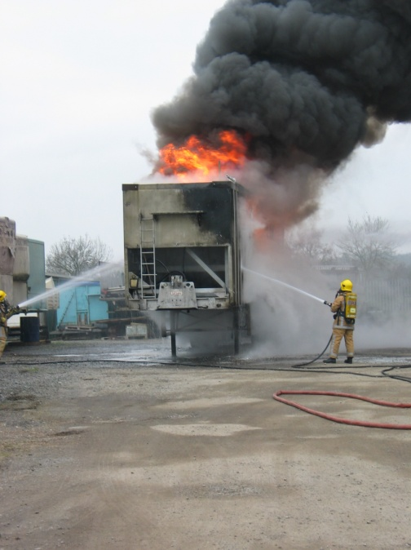
7 Frequently Asked Questions

How much cover do I need to give?
You may wish to offer evening, daytime or weekend cover, with full time cover being 120 hours plus and three-quarter cover anything less than 120 hours a week but more than 84 hours a week, however, we are committed to offering flexible working hours to ensure a healthy work/home life balance.

How often will I be called out?
On average you’ll be called out about 2-3 times a week dependant on your station area. In hot summers you may be very busy with grass fires. Alternatively, during prolonged wet periods, you may attend lots of flooding incidents. No two calls are ever the same!

Can I go shopping/visiting/out whilst on call?
Yes, but you must make sure that you carry your pager and that you can still get to the station within 5 minutes. If you need to go further afield you may be able to arrange for an off duty member of your team to provide cover for you. Please remember whilst you are on call you must be fit for duty.

What if I can’t do the same hours every week or I need to change the hours I do?
You need to commit to a certain number of hours to get your retaining fee, but there will be some flexibility depending on the availability of the rest of the team to change hours of cover.
Any change to the agreed cover you provided at appointment will be considered by the service and if it no longer meets the needs of the service your contract may be terminated.

Do I need any qualifications?
No, but you will need to pass selection tests.

Are there height limits?
There are no maximum or minimum height limits.

If you have any further enquiries please contact the Human Resources (HR) team on 01743 260223/212.

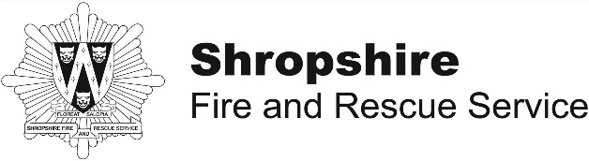 | Job Description

Post | On call Firefighter | Post No
Line Manager | Watch Manager | Location
Directorate | Area Command
Scale | On-Call Firefighter  Trainee | Current Salary | £2,202 Full Cover  £1,651 3/4 Cover
Duty System | On-Call Duty System | Status of Post | Permanent

1 Job Purpose

  - As a Firefighter, your two primary roles within the community are safety and operations. With the appropriate level of support from your Station Management Team you will be expected to exercise good judgement in the performance of your duties. You are the deliverers of the Service’s objectives and therefore you are able to make the most significant contribution to the safety of the community.

  - You will be required to fulfil the role of a firefighter under the nationally agreed role Map, in accordance with your conditions of service, a copy of is attached to this job description.

- Major Tasks

  - Service Delivery

- Respond, attend and resolve operational incidents and work as part of a crew under the direction of an Incident Commander and implement Standard Operating Procedures as appropriate. Protect the environment from hazardous matter.

- Minimise distress and suffering to members of the community by saving and preserving life and administering first aid as appropriate.

- Carry out Fire Safety and other inspections to minimise risk to the community, to firefighters and to the environment and assist in the development of contingency plans.

- Report on issues arising from inspections and investigations of premises.

- Assist in the development and maintenance of links with the local community and inform and educate the community to improve fire safety awareness.

- Develop your knowledge of streets, roads, buildings, housing and industrial estates, fire hydrants and other water supplies situated on your own station’s ground.

- Be aware of risks and potential hazards to be found on your own station’s ground.

- Develop a knowledge of, and operate, vehicles and equipment as directed.

2.2 Personnel and Training

- Participate in training programmes as directed.

b) Co-operate with managers to identify areas of your training needs and assist in the development of programmes to meet those needs.

c) Maintain individual training and personal development records in accordance with Service policy.

d) Maintain an understanding of the contents of the Fire Service Operations Manuals, Brigade Orders, Standard Operating Procedures and Special Incident Procedures commensurate with the role of a firefighter.

e) Participate as an effective team member.

f) Maintain self-discipline, proper behaviour, conduct and standards of dress whilst on duty in accordance with Service policies and procedures.

g) Support the development of your colleagues as professional firefighters.

h) Assist in the development of colleagues, for example, through the delivery of training sessions at station level.

2.3 Administration and Premises

- Maintain proper administrative procedures and records as directed by managers.

Other Tasks

  - Ensure that the Service’s policies on equality and diversity at work are implemented, monitored and adhered to at all times, in order to achieve a working environment that promotes equality and diversity. Be sensitive to the feelings and needs of others.

3.2 Carry out the duties of other firefighters as and when required.

3.3 Carry out such other duties as may be directed, commensurate with the grading of the post.

  - Support the organisation in embedding the ‘core values’, strategic aims and corporate objectives.

  - Ensure all duties are carried out in accordance with the Authority’s IT Security Policy.

  - Comply with the Health and Safety responsibilities set out in Appendix A to this job description.

  - Maintain proper administrative procedures and records in accordance with Service policy, orders and instructions.

  - Ensure that the Fire and Rescue Service’s policies, procedures and standards are complied with by self and all employees.

  - Contribute to special projects and teams, commensurate with your experience and role, as and when required.

- Status of job description

4.1 January 2015

Safety Responsibilities Appendix A

Individual Employees

- Each employee is responsible for their own acts or omissions and the effect that these may have upon the safety of themselves or any other person.

- Every employee must use safety equipment or personal protective equipment (PPE) in a proper manner and for the purpose intended.

- Any employee who intentionally or recklessly misuses anything supplied in the interests of health and safety will be subject to disciplinary procedures.

- Every employee must work in accordance with any health and safety instruction or training that has been given.

- No employee may undertake any task for which they have not been authorised and for which they are not adequately trained.

- Every employee is required to bring to the attention of their supervisor/manager any hazard or perceived shortcoming in our safety arrangements.

- Every employee must report any near miss, accident or dangerous occurrence that they witness or are involved in.

- All employees must co-operate with their employer to ensure legal requirements are met and the highest standards of safety management are maintained.

- Every employee must observe correct manual handling techniques when lifting carrying or moving a load.

- Every employee must follow the Service General Health and Safety Rules.

Firefighter

Ff 1 | Inform and educate the community to improve awareness of safety matters  Promote safety matters to inform your community.  Facilitate learning through demonstration and instruction.
Ff 2 | Take responsibility for effective performance  Take responsibility for personal performance  Establish and maintain effective working relationships with people  Develop your own skills to improve your performance
Ff 3 | Save and preserve endangered life  Conduct a search to locate life involved in incidents.  Rescue life involved in incidents.  Provide treatment to casualties.  Support people involved in an operational incident.
Ff 4 | Resolve operational incidents  Control and extinguish fires  Resolve incidents other than those involving fire or hazardous materials  Support people involved in an operational incident
Ff 5 | Protect the environment from the effects of hazardous materials  Mitigate damage to the environment from hazardous materials  Decontaminate people and property affected by hazardous materials  Support people involved in hazardous material incidents
Ff 6 | Support effectiveness of operational response  Collect information on risks in your community  Collect information on resources in your community  Maintain internal resources
Ff 7 | Support the development of colleagues in the workplace  Communicate your own skills and knowledge to colleagues in the workplace  Support the development of colleagues
Ff 8 | Contribute to the safety solution to minimise risks to your community  Inspect premises to minimise risks to people, property and the environment.  Report on issues arising from inspection.
Ff 9 | Drive, manoeuver and re-deploy fire safety vehicles  Drive vehicles to incidents  Manoeuver, site and re-deploy vehicles

Appendices

Appendix 1

Table 1 Retained Duty System Initial Training Course

Week
1 | 6 day Induction Course at the Service Training and Development Centre (normally Monday to Saturday).
2- 6 | Pumps and Ladders training carried out at T & D Centre Telford Central and on station.
7 | Support Programme and Assessment Weekend carried out at T & D Centre Telford Central (Saturday and Sunday)
8 | Water Safety Awareness Training carried out at T & D Centre Telford Central.
9 | Phase 1 Line Safety carried out at T & D Centre Telford Central
10 | Breathing Apparatus Course carried out at T & D Centre Telford Central (Two week course).
11 | Phase 1 Line Safety carried out at T & D Centre Telford Central
12 | Phase 2 Line Safety Weekend carried out at T & D Centre Telford Central (Saturday and Sunday)
13 | Trauma Care carried out at T & D Centre Telford Central
14 | Trauma Care carried out at T & D Centre Telford Central
15 | RTC Weekend carried out at T & D Centre Telford Central
16 | Critical Incident Debriefing Introduction carried out at T & D Centre Telford Central
17 - Onwards | On the Run Day.  Training carried out on station to be conducted based on Firefighter Development Programme.  Upon completion of initial training, you are required to complete a suitable development programme. The Development Programme is expected to be completed within 3 years of commencement of study. The programme is designed to ensure you develop and consistently demonstrate, over a period of time, the necessary skills required to be a fully competent Firefighter.

