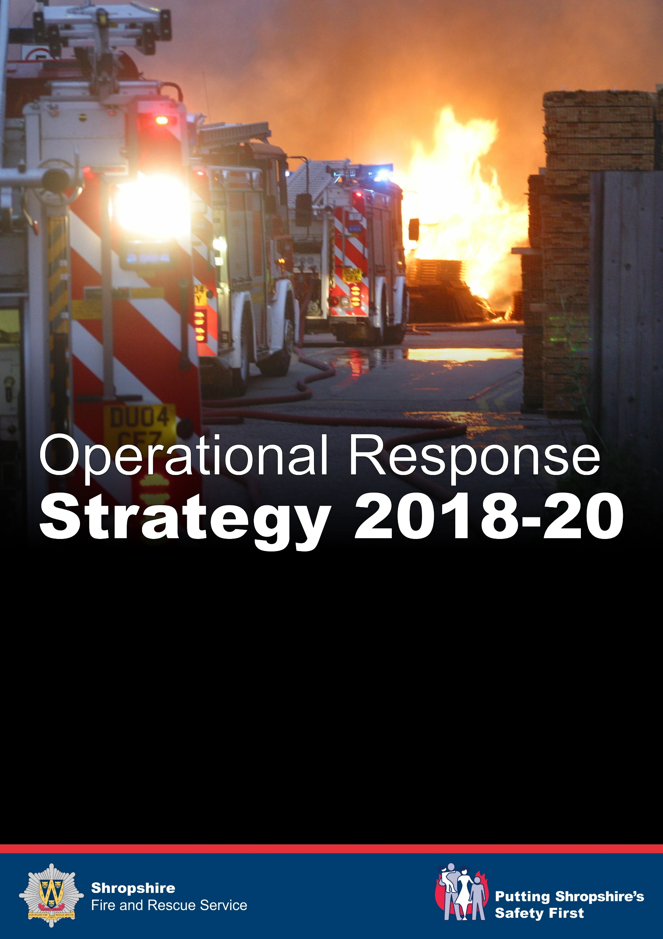

**Shropshire Fire and Rescue Service Response Strategy**

**Purpose**

The Services Response Strategy outlines how Shropshire Fire and Rescue Service (SFRS) identify and manage risk through our Integrated Risk Management Plan (IRMP) and details how we are striving for continual improvement, involving a range of change management projects as well as Service Transformation that will evolve and improve the way we work internally along with partners to enhance public safety and reassurance, whilst also ensuring the safety of our people.

The strategy also demonstrates how we effectively deliver our statutory response duties outlined within the Fire and Rescue Services Act 2004, Fire and Rescue National Framework Document, The Health and Safety at Work Act 1974 and the Civil Contingencies Act, and continue to be a high performing Fire and Rescue Service.

This strategy will be reviewed in line with IRMP to ensure accuracy and adequacy of content.

**Introduction**

Shropshire Fire and Rescue Service covers an area of 3,490 square Kilometres and is the largest inland County within England. To ensure excellent delivery of services we operate from 23 strategically located sites across Shropshire.

The Service has 3 whole-time stations located in Shrewsbury, Telford and Wellington, which deliver a 24/7 response capability with staff who work from each location. On-call firefighters operate from 22 stations and ensure we are in a position to undertake emergency interventions across the whole of Shropshire, through responding to emergency calls from their normal place of work or home.

The risks faced by the Service range from the challenges posed by the predominately rural, sparsely populated community, through to the potential impact of emerging threats including international terrorism.

Shropshire is home to approximately 473,000 people living in 214,000 residential dwellings and its communities present many challenges and risks.

**Overarching Response principles**

Shropshire Fire and Rescue Service strive to provide a safe and effective response to foreseeable fire related risks within the County that are identified within our IRMP. We are committed to driving efficiency through effective planning and working closely with partners to ensure excellent delivery of response services. This approach to collaborative working also sees us providing appropriate support to regional and national deployments. This work is also supported through Shropshire Fire and Rescue

Service maintaining National assets and providing competent and professional people. An example of this is the High Volume Pumping Unit based at Prees.

Through ensuring effective internal and external communications channels, we use appropriate data from our response activity to drive and shape our Prevention and Protection work, with the overall aim being to have the right person, with the right skills and equipment in the right place at the right time, whether it be through Prevention, Protection or Response activity.

**Service aims**

To enable understanding of our aims and objectives, we produce an Annual Plan which provides measures and targets that are intrinsically linked to our service aims, which are;

1. To be there when you need us in an emergency with a professional and well equipped team.
2. To reduce the number of fires in our community.
3. To reduce the number of fire related deaths and serious injuries.
4. To deliver a fire and rescue service, which provides value for money for our community now and into the future.

To achieve these aims, it is critical that this strategy is considerate of all areas of the service so that maximum benefits from collaborative working can be achieved, therefore providing value for money and efficient and effective ways of working. Examples of this can be found in links with the Prevention and Protection Strategy, Asset Plan, Fleet Strategy, People Strategy, Training Strategy and ICT Strategy.

**Response Challenges**

According to latest fire statistics (Jan- Dec 17) there has been a 1% increase compared with the previous year, but a 34% decrease compared to ten years ago. This National data is comparable with our service and some of this reduction can be attributed to our efforts in relation to Prevention and Protection activities which are outlined within the Prevention and Protection strategies. Although this should be viewed as a success, it also presents challenges for the service in relation to exposure and experience of staff. It is therefore critical that our people are highly trained and competent to deal with emergencies in a safe and effective manner, therefore limiting damage to life, property and the environment. Our approach to ensuring operational excellence can be viewed within our Training Strategy.

What is also apparent from Home Office statistics is that Fire and Rescue Services are now attending non fire related incidents which are placing similar demand on response assets as that for fire related incidents. This also presents challenge for the service due to the need to ensure staff are competent in an expanding and evolving skill base, which also impacts upon other matters such as time requirements and investment in terms of finance and equipment which are outlined within the Asset Plan and Fleet Strategy.

Challenge is also faced in terms of reducing budgets which are driving efficiencies, so it is imperative we continue to identify and implement new and innovative ways of working that continue to secure public and firefighter safety. Our collaborative and inclusive approach to service improvement will continue to ensure we are able to provide excellent services whilst also evaluating value for money in everything we do**.**

**Demand**

When seeking to ensure we have an effective response model it is important to understand demand. This can be broken down into:

**Predictable Demand -** When analysing historical data, we are generally able to predict demand and our IRMP outlines our approach to risk and how it is managed, however the challenge posed relates to where and when an incident will occur. This means that our response model of whole-time and on-call staff is required to maintain a flexible and agile approach to meet dynamic demands on resources across a large geographical area.

Less common but predictable incident type’s impact upon the service as there is a requirement to deploy the right person, with the right skills and equipment to the right place effectively. To achieve this, we need to ensure our staff are adequately trained and proficient to respond effectively.

There is a direct correlation between domestic risk and density of population within the County and our response model reflects this through the use of whole- time crewing models within the two areas of Telford and Shrewsbury, with On- call; resources spread through rural parts of the County especially in the market towns and larger villages. Continual work to reduce instances of domestic fires is delivered through our people and is outlined within our Prevention strategy and AFD Plan.

As a Service, we continue to enforce the Regulatory Reform (Fire Safety) Order 2005, with this work being undertaken primarily by our Protection Team with assistance from Response staff and also partners. Our approach is outlined within the Protection Strategy. Commercial risk is apparent throughout the County and covers a wide range of businesses. Our overarching aim is to assist businesses to prosper and mitigate damage when an emergency occurs. Adopting the principles of Better Regulation and providing a safe, effective and assertive response capability enables protection of businesses and therefore supports economic growth within the County.

**Variable Demand-** There are occasions where it is not possible to identify trends, however an incident of this nature can place considerable demand on our response capability. Examples of these types of incidents would involve;

* Emerging threats- such as terrorist related incidents of any kind
* Weather related incidents- such as flooding and storm related damage
* Regional and National deployments- These incidents reduce our resources within the County for the period of deployment, however this can be managed through effective liaison with Fire and Rescue Service National Co-ordination Centre (FRSNCC) if national assets are involved.

Shropshire Fire and Rescue Service will work in collaboration with a range of partners to resolve incidents within the County that have the potential to cause widespread disruption. This is achieved through playing an active role in the Local Resilience Forum for West Mercia. We also work with partners to produce a Community Risk register that reflects all foreseeable risk from a range of incidents and supported by the National Risk Assessment.

**Our Response Resource**

Shropshire Fire and Rescue Service has 23 stations;

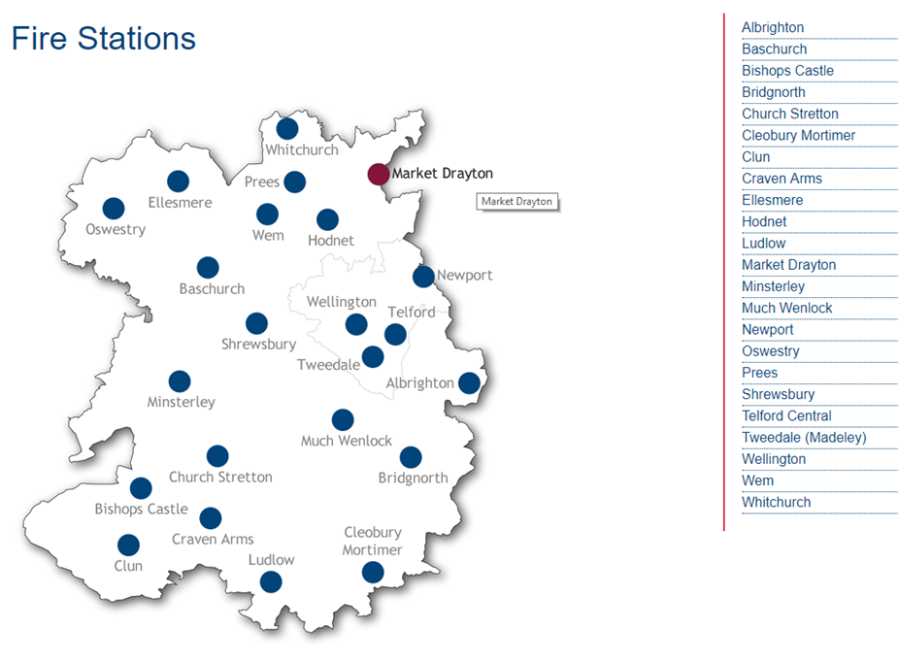

Our stations are strategically located across the County and a mixture of Whole-time and On-call crewing models. To support a safe effective and assertive response there are a range of resources available across the County.

**SFRS Appliance Resources**

To achieve the current operational model SFRS needs to have a broad range of appliances, equipment and personnel with specialist skills that can be deployed individually or as part of a team. The allocation of resources demonstrates how SFRS are committed to providing our people with the right equipment to ensure they are able to deal effectively with incidents, whilst also maintaining the safety of our teams.

The following section provides an overview of some of the Service’s resources. Further information on individual stations can be found in the SFRS Station Profile document available at: www.shropshirefire.gov.uk

**28 x Frontline Fire Appliances**

**10 x Incident Support Units (ISUs)**

**1 x Prime Movers (PMs)**

**2 x Aerial Ladder Platforms (ALPs)**

**2 x Incident Command Units (ICUs)**

**1 x Rescue Tender (RT)**

**1 x Water Rescue Unit (WRU) consisting of 2 boats**

**1 x Water Carrier (WC)**

**1 x Pinzgauer (L6P)**

**2 x Light Pumping Unit (LPU)**

**1 x Foam Pod (FP)**

**1 x Environmental Protection Unit (EPU)**

**1 x Welfare Unit (WU)**

This fleet of resources is supported by our dedicated team of workshop technicians who ensure fleet availability, whilst the identification of future firefighting capability inclusive of water provision, new technology and remote access vehicles is undertaken by our Operations Team and ensures we are providing the right equipment in the right place, to deal effectively with incidents.

**Systems and Information Technology**

To support the effective deployment of our fleet, we ensure that technology is embraced and utilised, such as mobile data terminals (MDT’s) which contain software that is able to relay critical safety information and considerations to our people when attending an incident, therefore increasing both firefighter and public safety, through pre identification and familiarisation of risk by operational staff.

This technology is supported by robust systems, processes and information to further support our people when faced with incidents. Examples of this include our risk management system and our alignment to national operational guidance, which provides consistency in the way all FRS’s approach similar incident types.

**Emergency Services Network (ESN)**

ESN will be the new communication system utilised by the three emergency services and other public safety users in the UK and will provide the next generation integrated critical voice and broadband data services.

SFRS are currently at a crucial stage of exploring an incremental approach to ESN, this involves the release of five different ESN products which will be available for adoption as early as Q4 2018, with the full ESN network becoming available in Q3 2020.

Within each of these product releases, the Services Emergency Services Mobile Communications Programme (ESMCP) Team have identified a number that can potentially be adopted locally, these include:-

* MDT replacement
* New mobile phones
* Tablet procurement
* Changes to the methods of alerting/mobilising – both critical and non-critical.

The team are also fully engaged with the ESMCP Regional Management Team and EE to ensure areas of poor coverage are identified, and are working towards bringing together a Coverage Assurance Strategy.

In addition to ESN, SFRS along with Hereford and Worcester Fire and Rescue Service (HWFRS) have entered into a joint procurement project for replacement Integrated Communication Control Systems (ICCS). Although not specifically an ESMCP project; it is very closely linked as the ICCS will be required to be ESN compliant.

**Fire Control**

Our response is supported by our highly skilled Fire Control Staff, who play an integral role in our operations through call handling, information gathering, deploying appropriate assets and managing incident logs, whilst also providing appropriate guidance and support to those in need.

SFRS Fire Control is based in the Headquarters building in Shrewsbury. It consists of 4 operating terminals, featuring the SEED Command and Control mobilising system and an integrated telephony system. These systems enable Fire Control operators to receive all emergency calls, mobilise all of SFRS resources and contact other agencies involved in incidents.

**Officers**

Our Group of Operational Officers provide support to our crews and also incorporate specialist skill sets such as Hazardous Materials and Environmental Protection Officers as well as National Inter Agency Liaison Officers who working closely with our blue light partners. We continue to work closely with other agencies to resolve operational incidents such as Environment Agency, Local Authorities and voluntary organisations such as the Red Cross who assist those affected through compassionate support and also advise on appropriate courses of action to return to normality where possible.

**Partners**

SFRS has worked with its partners through the Joint Emergency Interoperability Programme (JESIP) to improve the ways in which the Service, responds to major and complex incidents, locally, regionally and nationally. The JESIP Assurance visit undertaken in early 2017 identified that the Service had a very positive attitude towards JESIP as well as recognising the positive impact it had on improving interoperability locally and beyond.

Work continues with partners and SFRS are embedded within the Local Resilience Forum and contribute to the West Mercia Community Risk Register, preparing and planning for major risks within our area. This valuable work not only contributes locally, but also influences nationally in regards to approaches and mitigation factors applied to reducing risk, which can be found within the National Risk Register.

**Standards of Response**

To support our ethos of having the right people in the right place with the right skills and equipment at the right time, we provide response standards based upon the nature of the incident. These being;

* The first fire engine will arrive at an emergency incident with at least 4 firefighters within 15 minutes on 89% of occasions.
* The first fire engine will arrive with a minimum competent crew of 4 staff on 100% of occasions.

However, in order to drive performance improvement, the Service will continue to measure standards in more detail for specific incident types:



This table is derived from historical National standards of fire cover that also supports our Pre determined attendance.

In terms of ‘weight of attack’, we have constructed pre-determined attendance criteria for all emergency incident types. This ensures that Fire Control deploy the right number of people, with the right skills and the right equipment to every incident.

In addition to the response standards outlined above, we also have a resilience standard, which relates to the minimum level of response we deploy during exceptional periods of demand on operational resources. This has been set as at least one fire engine to anywhere within the County within 20 minutes.

**Continual Improvement**

SFRS recognises the importance of adopting National Operational Guidance (NOG) in its entirety and that this will be supported by a suite of local policies, procedures, training packages and equipment notes. Adoption will impact on many departments within the Service, all of whom are regarded as stakeholders within the Services implementation framework.

Our people are constantly seeking to identify more effective and efficient ways of working and this is evidenced through our commitment to Service Transformation and change management projects, which overarch all areas of the service. Examples of this include new staffing models, the introduction of a new command and control vehicle in collaboration with Hereford and Worcester through a strategic alliance and nearest Officer mobilising.

To ensure we continue to provide an excellent service to our community, we must continue to be innovative and flexible in the way we manage and deal with emergencies.

We recognise that it is very rare for us to respond to an emergency on our own and we will continue to carry out joint planning with our partners to ensure we are prepared to deal with all types of emergency on a local, regional and national scale. We will always ensure that when we are required to respond, we will do so in a timely manner with the right staff, who have the right skills, the right equipment and the right support.

We must also be prepared to think differently about the tactics we employ to deal with and manage emergencies. Accordingly, this new approach must embrace a preparedness to be more adventurous in learning from operational incidents and to think about different approaches to dealing with emergencies. Finally, we must be prepared to be ambitious and there is no reason why Shropshire Fire and Rescue Service cannot or should not achieve excellence whilst at the same time, achieve our planned efficiencies and demonstrate excellent value for money.