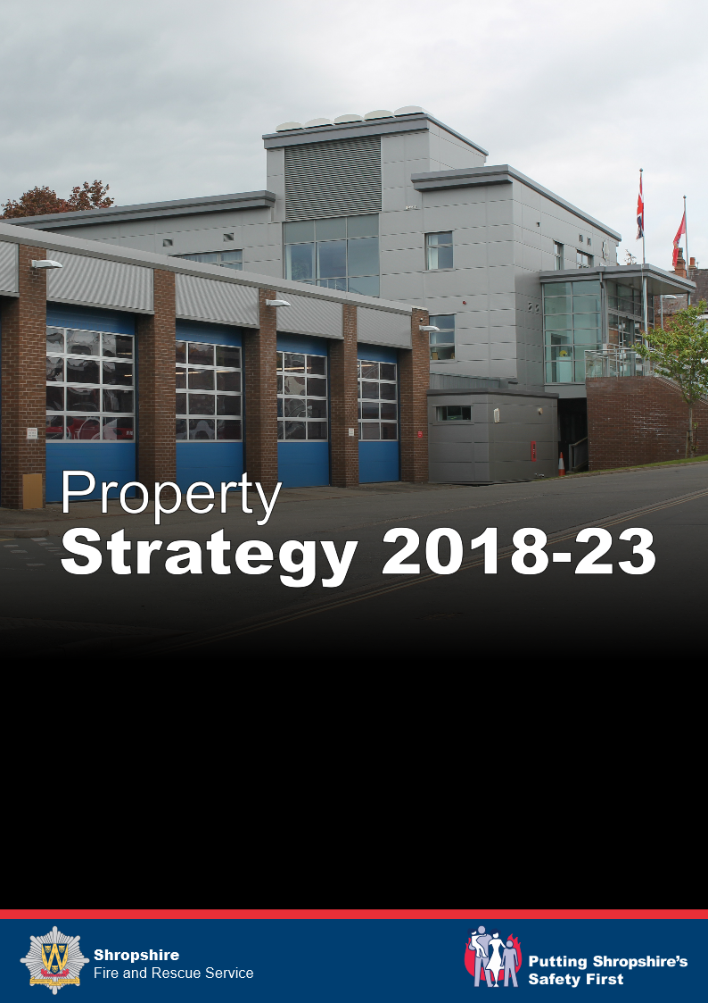

Shropshire Fire and Rescue Service
Property Strategy 2018 - 2023

Strategy Purpose
The Service’s Property Strategy exists to ensure that property is provided to meet the needs of the Service in delivering services to the community.
Those services are defined in corporate aims and objectives, and detailed within the Integrated Risk Management Plan.
The Integrated Risk Management Plan establishes the number of fire stations required, their locations, and the services to be provided from them.
The Asset Management Plan considers the established property needs, compares it with the current estate, and proposes actions to more closely align need and provision.
Strategy Structure
The full Property Strategy consists of a number of interlinked documents:

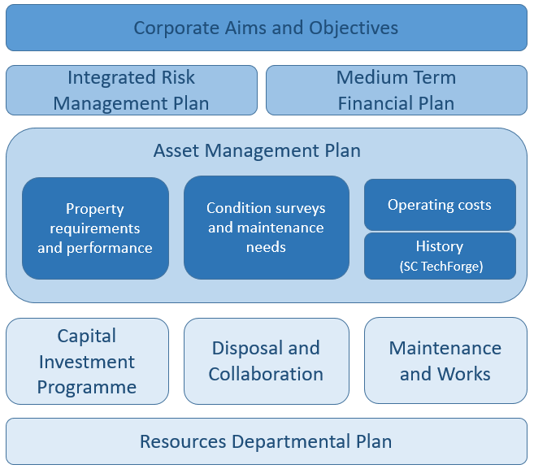

Property Objectives
The Service aims to have an estate which:
- Supports operational service delivery and improvement as detailed in the Integrated Risk management Plan
- Provides training facilities which support a safe and effective workforce
- Is safe and healthy by design, supporting healthy behaviours and the wellbeing of employees
- Is secure and resilient against a wide range of threats, including theft, flood, fire and loss of utilities
- Enables community use, while not competing with existing community facilities
- Meets statutory requirements, regulations, and identified best practice
- Supports a diverse workforce and community
- Provides a good and motivational workplace, which is a pleasure to use, visit, and observe
- Is sustainable and efficient
- Is flexible for future development and collaborative working
- Demonstrates and promotes the Shropshire Fire and Rescue Service brand and values
- Uses standard products and open protocol systems to ensure maintenance flexibility, including opportunities for local SME’s
Property Structure
The Authority owns all the property assets, which are managed by the Service. This enables it to directly manage its occupancy costs, and ensure business continuity or flexibility without reference to other parties.
Property is managed by the Services Resources Department, who prepared this document and are responsible for strategic management of the estate. The department is supported by Shropshire Council who lead on compliance testing, planned and reactive maintenance, and by specialist architects and consultants for the delivery of major projects.
Current Position
Property assets are generally in reasonable condition and meet the Services requirements (with the exception of Clun, Much Wenlock, Tweedale and Telford Fire Stations) Sites are positioned to balance need and the availability of staff.
The summary statement of overall property provision against our objectives is below:
Service delivery | Good | Located in required areas
Training | Good | Facilities at all sites
Healthy | Inadequate | Safe but inadequate welfare facilities
Resilient | Poor | Inadequate security
Community | Poor | Accessible, but with no policy support
Regulations | Good | Compliant
Diverse | Good | A small number of sites are not accessible
Workplace | Inadequate | Some good, some poor
Sustainable | Poor | Most sites inefficient
Flexible | Inadequate | Limited flexible space at most sites
Values | Inadequate | Some good, some poor
Standard | Good | Traditional building products with limited technology

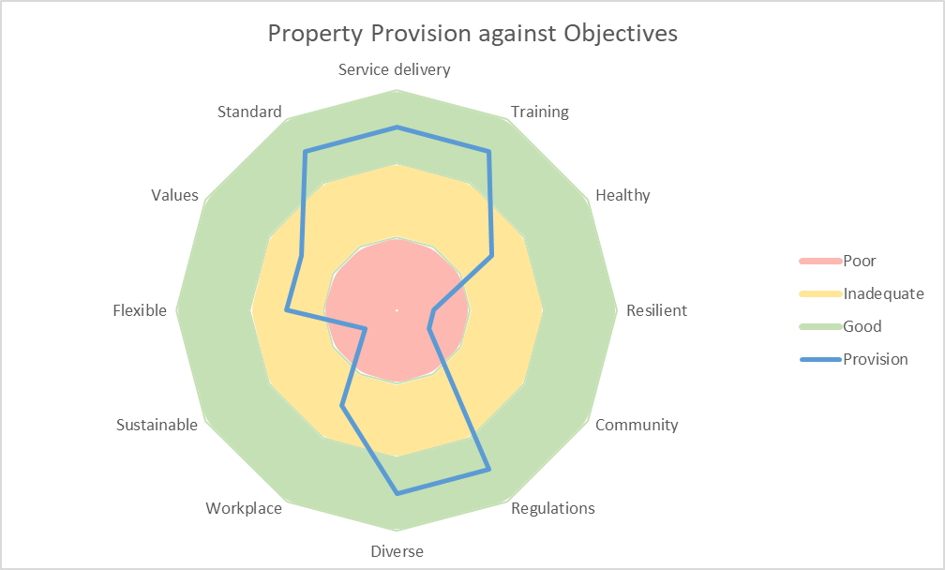
No surplus properties have been identified, however better use can be made of most sites.
There is generally a static estate, with no need for purchase or disposal of assets, however the Service remains open to any opportunity to rationalise its estate, or to support partners, and is an active member of the Shropshire Telford and Wrekin Estates Partnership.

Collaboration
While there are no clear opportunities for the Service to move to other properties, it has been made clear that Fire Stations are available for alternative use. Current schemes include:
Shropshire Telford and Wrekin Estates Partnership and One Public Estate. The Service is fully engaged with these projects to manage the public estate more effectively. It will use this as a way of delivering its own services more effectively, or to enable other parties to use its estate.
General sharing of Fire and Police properties. An agreement is in place to enable sharing of fire and police properties on an ad-hoc basis. This has been particularly effective at Newport Fire Station where police personnel regularly use the site to ensure they can remain longer in the community rather than returning to a police site for access to support facilities.
Bridgnorth, Whitchurch, and Church Stretton Fire Stations. West Mercia Police are looking to release property in these areas and have identified Fire stations as being appropriate alternative locations. The Service is fully supportive of this work and has offered to provide space on a non-commercial cost recovery basis (include peppercorn ground rent). It will be necessary in all cases for the Police to carry out improvement or extension works to meet their needs, and these investment decisions will remain with the Police. The Service has been fully involved in the development of the Police Property strategy.
Shropshire Council. The Service also works closely with Shropshire Council, as the main public sector property manager within the county, to share property maintenance contracts and resources.

Summary of Actions
The Asset Management Plan details a number of actions required to improve the estate and more closely align it to the needs of the Service, these include:
Investment
- Telford Central Fire Station. A major refurbishment of a 1970’s system built building in which a number of major elements have reached the end of their life. There are significant opportunities to improve collaborative working, training delivery and operational resilience within this scheme. A formal Programme has been established to enable delivery of these benefits at an estimated cost of £12,000,000.
- Clun and Much Wenlock Fire Stations. These two stations are the last remaining stations in need of extension works to meet the basic requirements for a fire station. Projects are in place to deliver these improvement.
- Tweedale. The role and requirements for the Tweedale site will be clarified as the design for Telford is developed. It is likely that significant investment will be required to meet these needs.
- Improved welfare facilities. Following work to improve the hygiene of protective clothing, the Service now wishes to ensure that more members of staff take showers following potential contamination. It has identified that improving the quality of provision will act as a ‘nudge’ towards this.
- Improved Security and Resilience. Due to increasing risk, the Service is looking to improve physical security at stations through changes to pedestrian and appliance door locking, door replacement, window replacement, and the installation of CCTV and alarm systems.
- Environmental Improvements. As part of its ISO14001:2015 Environmental Management System the Service wishes to invest in improved heating and lighting controls, and insulation. It will also invest in electrical generation and electric vehicle charging, where appropriate.
Maintenance
- Condition and Compliance. Continue with maintenance to the Authority agreed standard of safe, legal and no further deterioration.
- External appearance. Continue with external decoration, door replacement and signage works, driven by maintenance needs, in corporate colours.
Policy
- Continue to develop policies and procedures which enable and support community and partner use.

Current and Proposed Capital Schemes (2017)
The Authority have established a capital programme for investment in alterations and improvements to buildings. Revenue funding is provided for maintenance, including larger schemes (reroofing or resurfacing), which may have an extended life, but do not improve the building. A result of this approach is that a number of schemes will be funded from both capital and revenue, for example a roofing scheme which includes improved insulation may be funded from revenue for the roof coverings and capital for the insulation.
Current
Telford - £12,000,000. Requirements being developed and will include welfare, security and environmental improvements.
Clun - £550,000. Works on site and will include welfare, security and environmental improvements.
Much Wenlock - £450,000. Design being developed and will include welfare, security and environmental improvements.
Future Schemes, to be funded from previously agreed property investment scheme of £300,000 pa.
Welfare Facilities - £750,000. A 5-year, £150,000 pa capital scheme, supported by revenue funding, of internal refurbishment to retained stations, including improvements to shower facilities.
Environmental improvements - £750,000. A 5-year, £150,000 pa capital scheme, supported by revenue funding, to include window replacement, heating improvements and insulation. There is some crossover with security works, including more efficient and secure windows and doors.
New Schemes, to be submitted for Authority consideration
Security and Resilience works - £1,000,000. The Service must be confident that provided resources are always available for immediate operation. To ensure this it wishes to invest in security and resilience works including:
- physical security works appropriate to risk, to include physically secure doors, windows and other structural elements
- new door access controls to ensure ease of access for staff and approved partners, while excluding threats
- interlinked CCTV, intruder and fire alarms with remote monitoring capability
- supplementary power arrangements in the event of mains failure
Tweedale - £650,000. Requirements and capital scheme to be developed. The site requires accommodation, welfare, security and environmental improvements.
Revenue Spend
Property maintenance is funded at £300,000 pa, sufficient to maintain buildings at the agreed ‘safe, legal, and no further deterioration’ standard.
Environmental Management is funded at £40,000 pa, and some of this funding is used for minor property improvements to support environmental objectives.

How the proposed actions support the objectives

 | Action
Objective | Telford | Clun | Much Wenlock | Tweedale | Welfare | Security | Environment | Condition | Appearance | Policy
Service delivery
Training
Safe and healthy
Secure and resilient
Community
Regulations
Diverse
Workplace
Sustainable
Flexible
Values
Standard

