Sustainability and the Environment

We aim to provide a sustainable fire service, one which meets the needs of Shropshire’s current communities, without compromising the ability of other or future communities to meet their own needs. In order to do this we will actively manage the positive and negative impacts of our activities on both communities and the environment.

We have adopted an environmental policy to ensure that we actively manage our activities to minimise the negative environmental impact.

It is our environmental policy that:
We will actively manage our activities to minimise the negative environmental impact. We will take all measures reasonably practicable to meet, exceed or develop all necessary (including legal) or desirable requirements and to continually improve environmental performance through implementation of the following:

- Assessment and regular re-assessment of the environmental effects of our activities.
- Increase the understanding of employees and management in environmental issues and techniques. Implement arrangements to enable individuals to make improvements.
- Working with suppliers and other partners to assist in achieving this policy
- Managing waste to ensure compliance, recycling where possible and minimising the production of internal non-recyclable or non-reusable waste.
- Minimising wastage of energy, material, water and other resources.
- Minimising purchase of new resources through the effective maintenance and management of existing.
- Using recyclable, reusable and renewable resources (energy and materials) where possible.
- Maintaining or enhancing the natural and built environment
- Reducing and/or limiting the production of pollutants to water, land and air.
- Controlling noise emissions from operations.

It is our Objective to:
  - Actively manage our activities to minimise the negative environmental impact.

Our environmental performance is assessed using an environmental management system to ISO1400:2004, and reported annually through our statement of assurance.

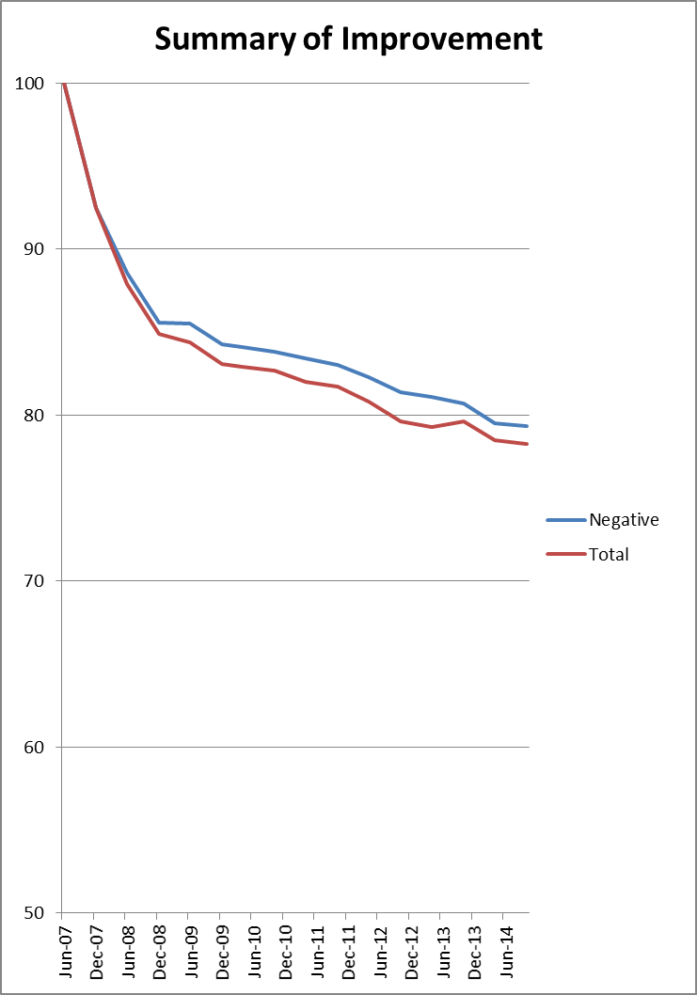
This graph shows our assessed environmental impact since the environmental management system was introduced in 2007. The blue line shows our activities which cause negative impact (harm) to the environment. It includes essential activities such as training firefighters and running fire appliances. The red line includes positive actions we have taken including offering environmental advice and support to other organisations.

